**Lecture 1**

**PCA**

1. Difficulties of point cloud processing: (1) sparsity; (2) irregular – difficulty in neighbor searching; (3) lack of texture information; (4) unordered – difficulty in deep learning; (5) rotation equivariance / invariance.
2. Method comparison:

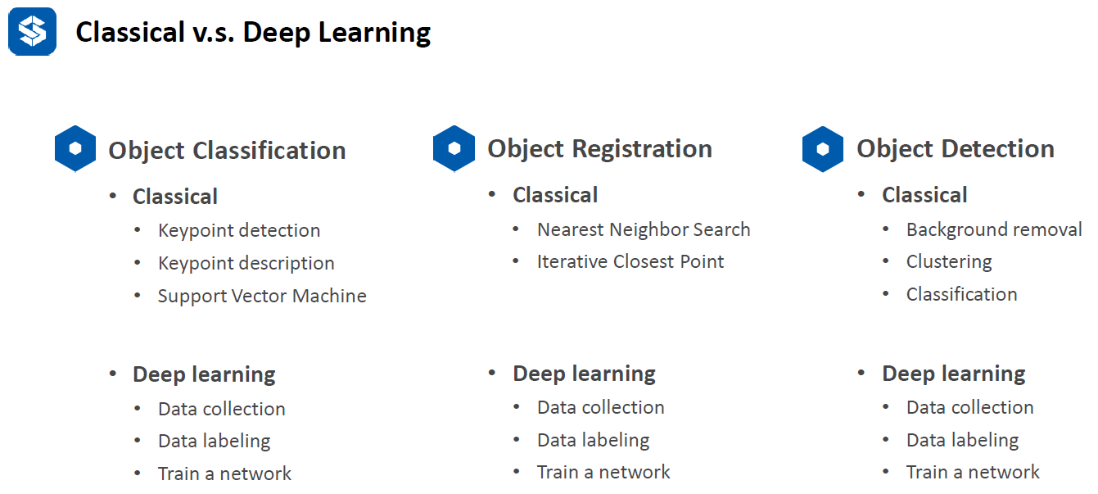

1. Principle Component Analysis (PCA): find the dominant directions of the point cloud
2. Application of PCA: (1) dimensionality reduce; (2) surface normal estimation; (3) key-point detection; (4) feature description; (5) canonical orientation.

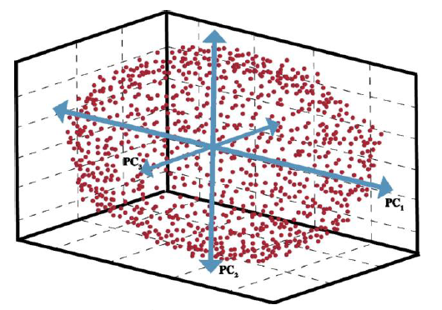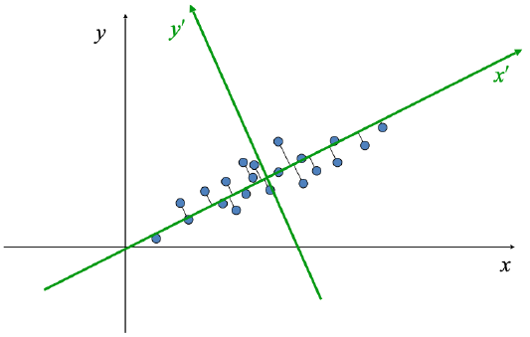

1. Principal component direction is the direction with **maximum** eigenvalues. This is because we care about the variance of the vector projected this direction should be maximum. When we apply the equation of Spectral theorem and Rayleigh Quotients, we can get the relation to achieve maximum variance is to get the maximum eigenvalues. Surface normal is the direction with **minimum** eigenvalues.
2. PCA and kPCA can be used for classification as well.
3. Vector dot product is just the projection of one vector to the other. 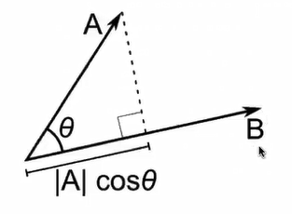
4. Matrix-vector multiplication is a linear combination of vectors. 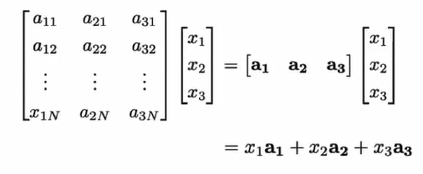
5. Singular value decomposition (SVD) is deformation and rotation of the geometry.

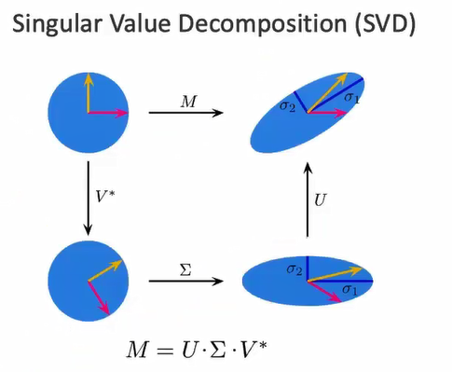i.e., (1) use V* to rotate coordinate system; (2) use Σ to scale the shape; (3) use U to rotate another direction. U and V is orthogonal matrix, they have rotation function; Σ is diagonal matrix, it has scaling function.

9. spectral theorem:

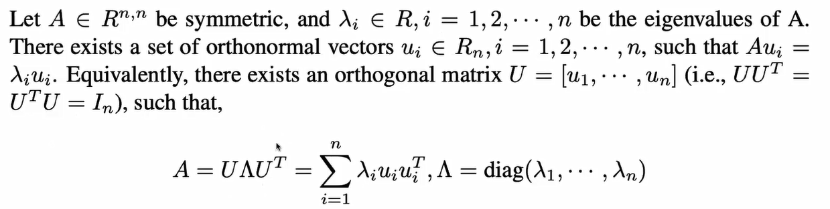

10. Rayleigh Quotients:

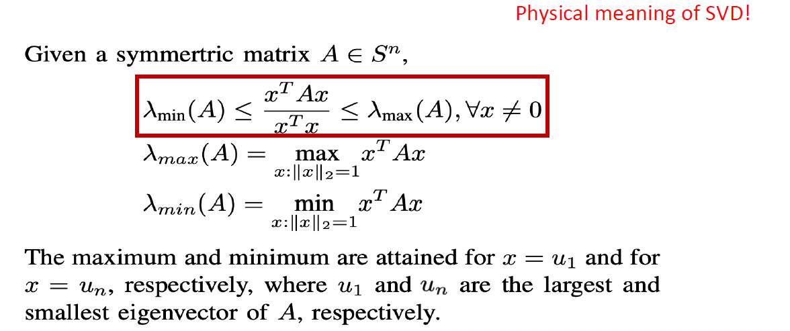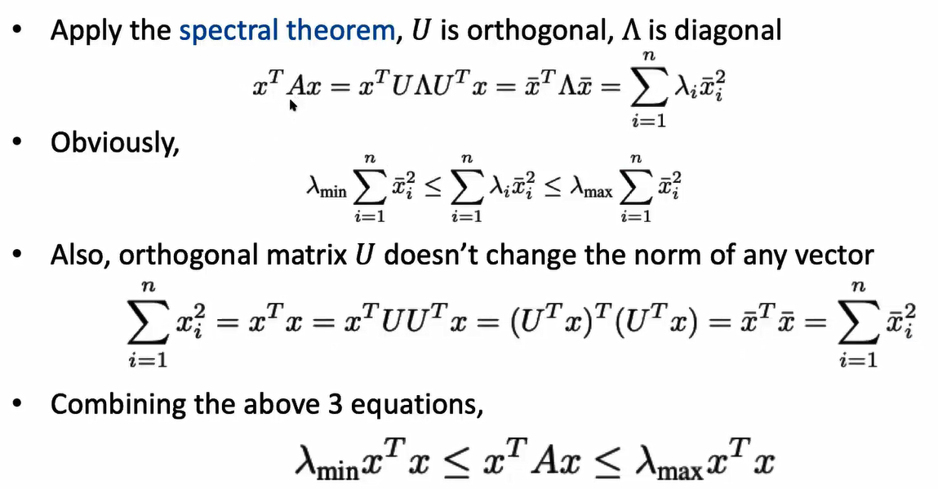

12. PCA: (1) input: a set of points; (2) output: principal vectors; (3) most significant principal component: maximal variance of projected data points on that direction; (2) get remaining significant components: deflation, that is, remove the higher priority component from the points, i.e., data point minus projection. Repeat for the rest.

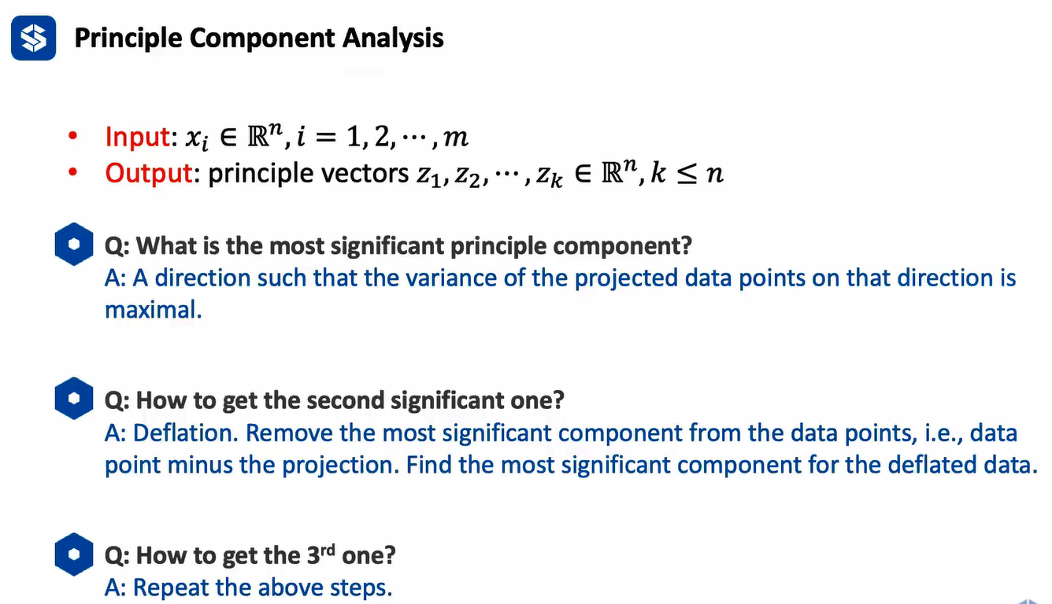

13. PCA proof: (1) normalize the data to be zero mean; (2) PCA purpose: get largest variance when projected to a direction, that is, vector *x* is projected to direction *z* (mod is 1), the result is their inner product which is the projection. (3) compute the mean variance of the projection. (4) compute the maximal variance; (4) H is covariance matrix, since X is already normalized and zero mean, so it is symmetric (think about normalization distribution), it can be applied to Spectral Theorem, which is XXT=UΣUT UΣUT=UΣ2UT, where UUT=1.(5) since U is orthogonal, the product of u1 and ui (i=2~m) will be zero, so only when i=1 there exists the result. (6) how to deflate: project all the data points to z1 direction, and use all the data points to minus this projected result.

14. physical meaning of PCA: for high dimensional data, we want to find a base which can be used to well present our data after projecting the high dimensional data to this base.

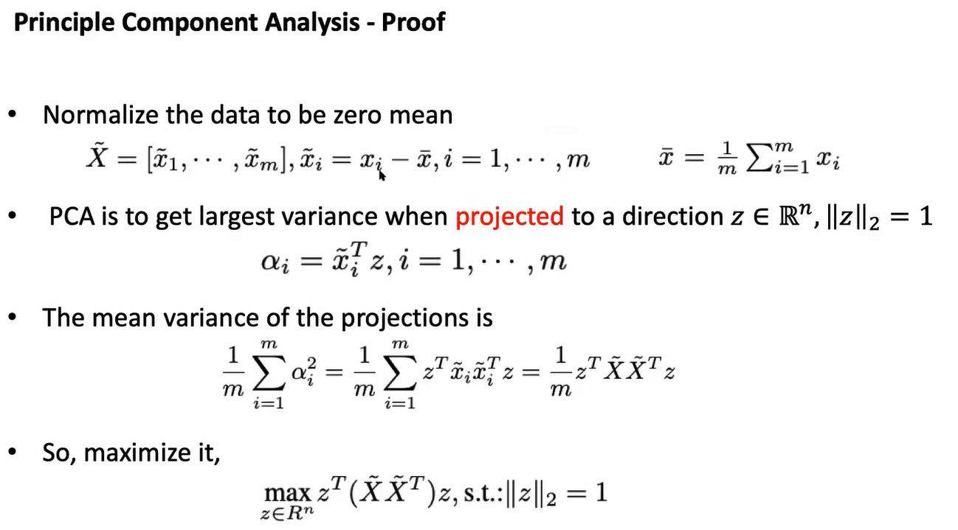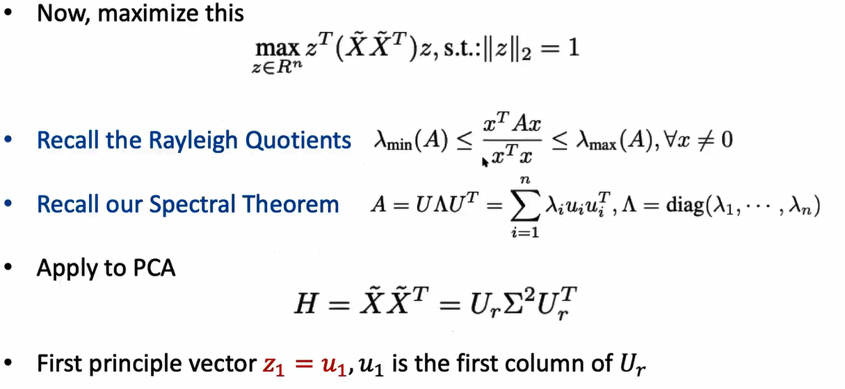

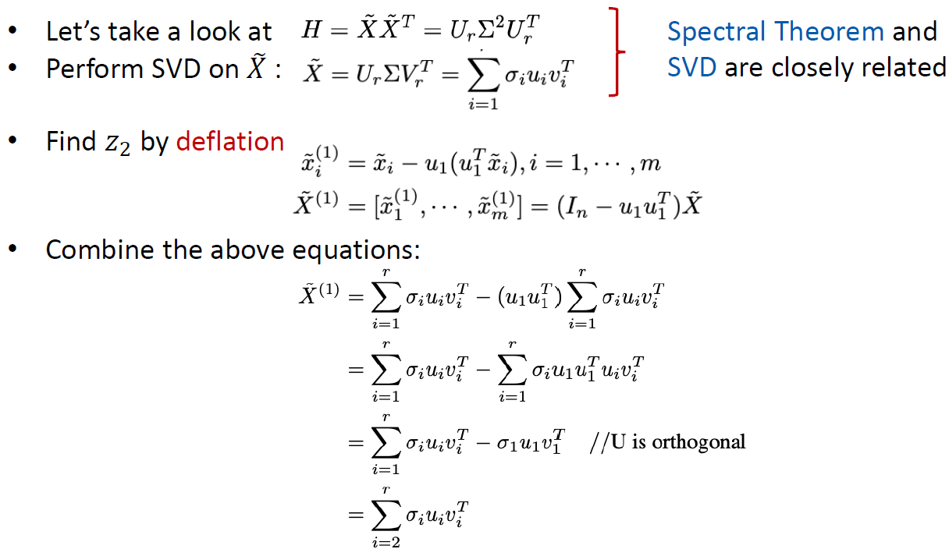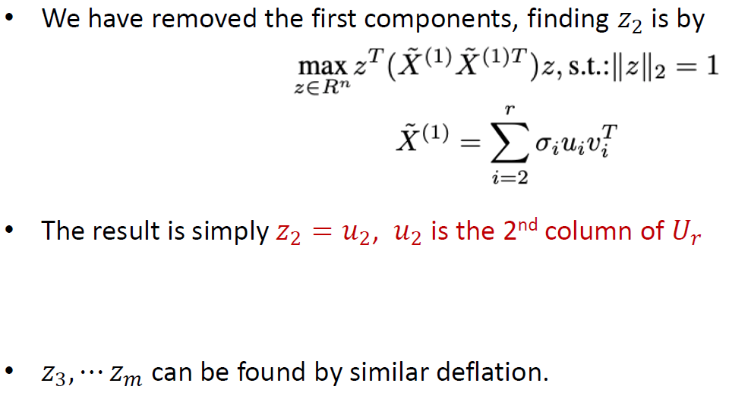

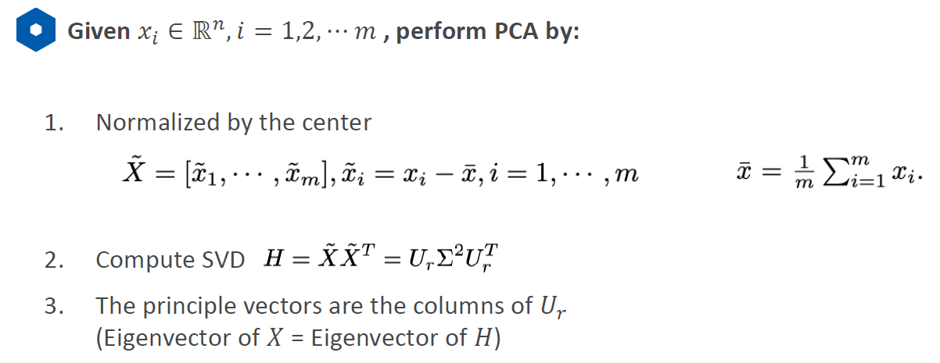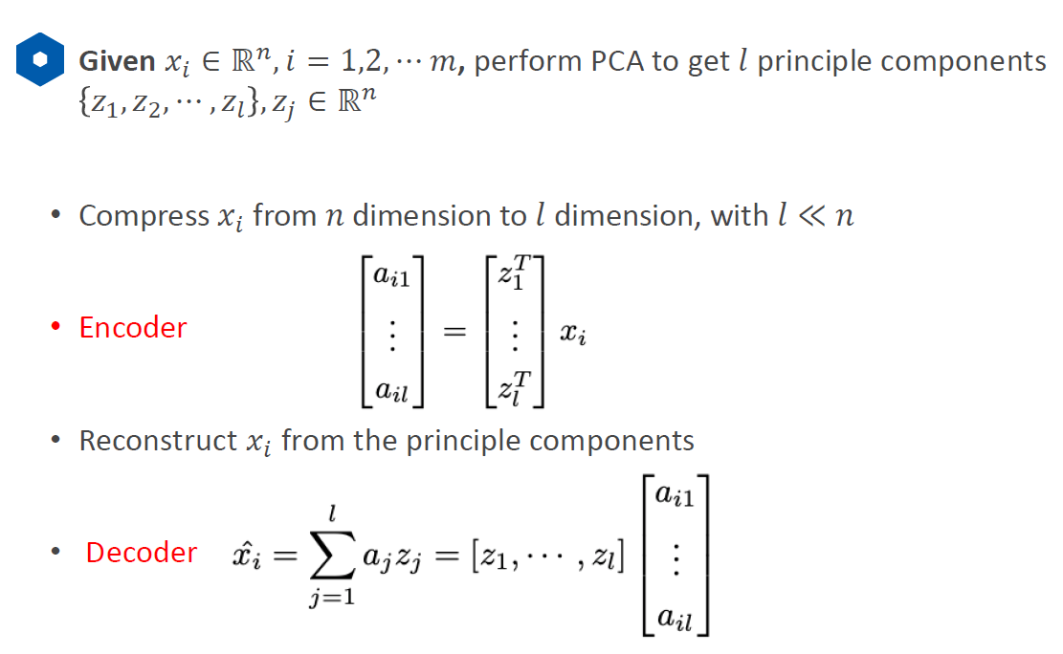

15. PCA application: dimensionality reduction. i.e., we have 100 dimensions, we want to project the data points to 10 principal components direction. For each data point, we will project that point to the 10 directions, the result matrix will be 10*100. As long as the number of the projected directions is smaller than the original dimension, it will loss some data point information.

**Kernel PCA**

1. PCA is linear. Why? Because the operation in PCA is about vector or matrix multiplication, which are linear operations in linear algebra domain. We want to handle non-linear data. How? Lift it to high dimension data.
2. Example:

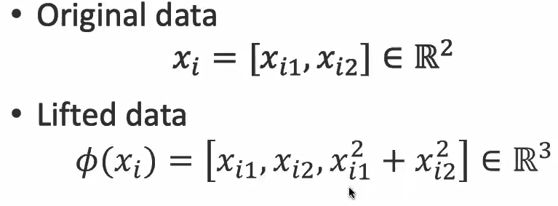

1. Kernel PCA process:

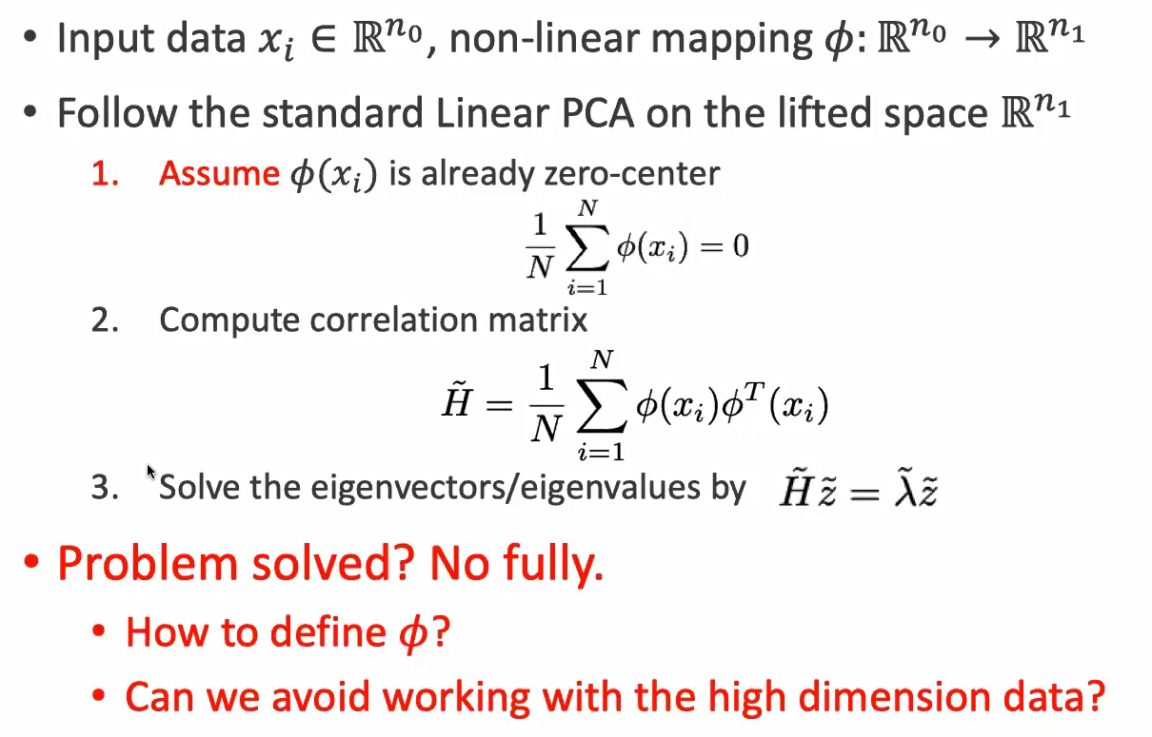

1. Because of the inner product of two vector, the result can only be scalar.

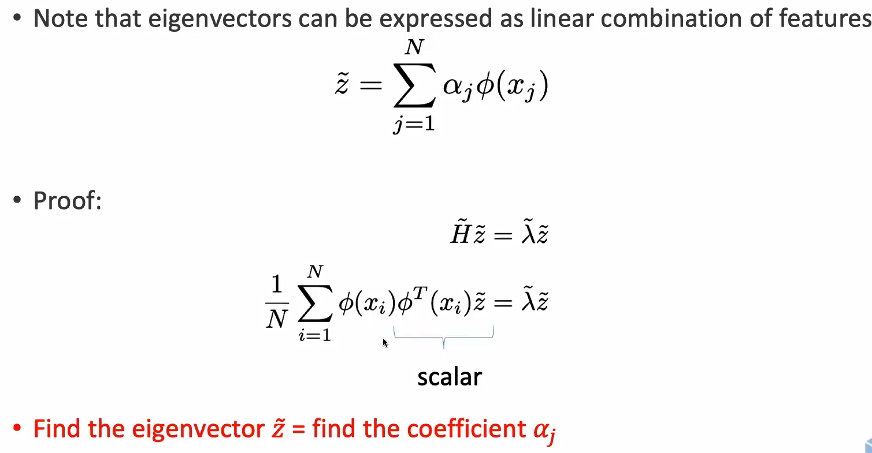

1. Kernel definition:

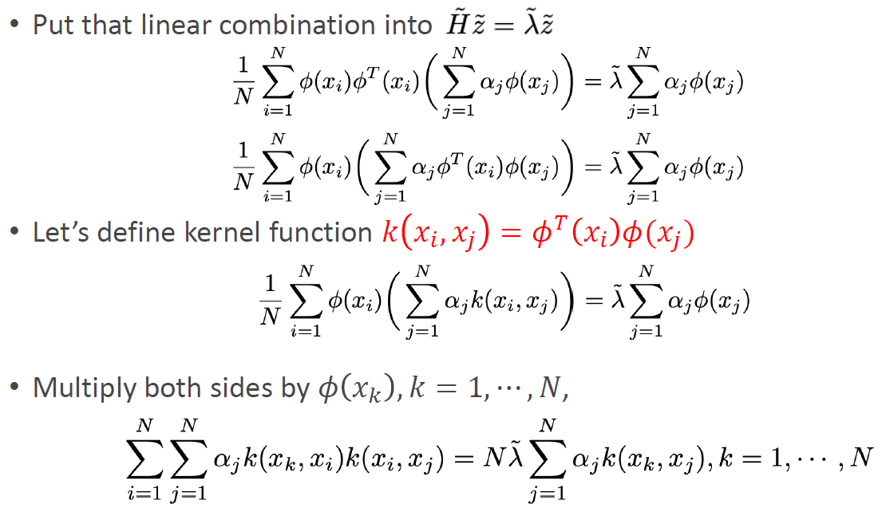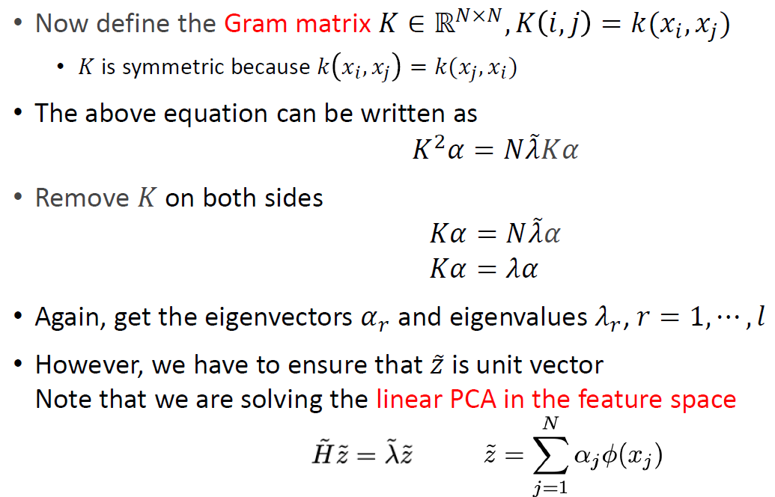

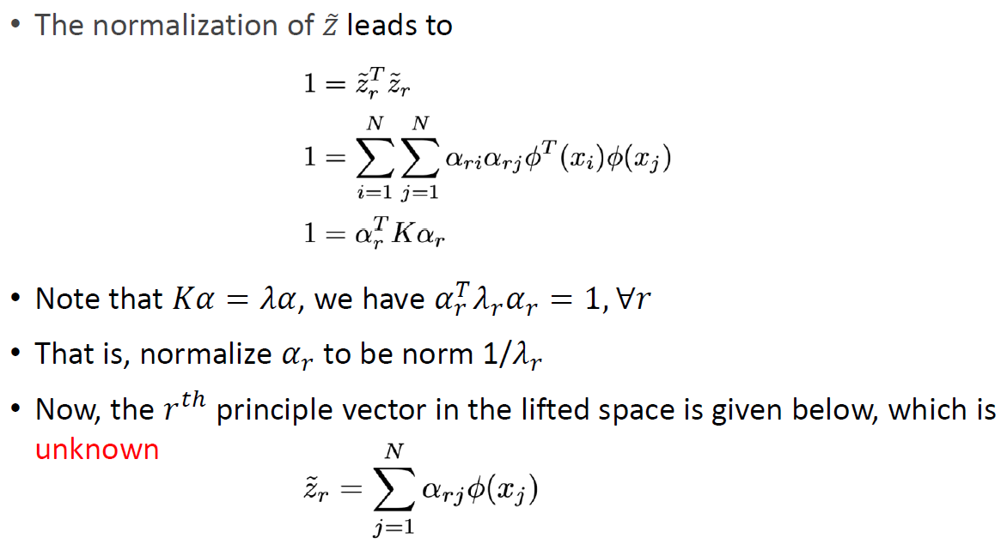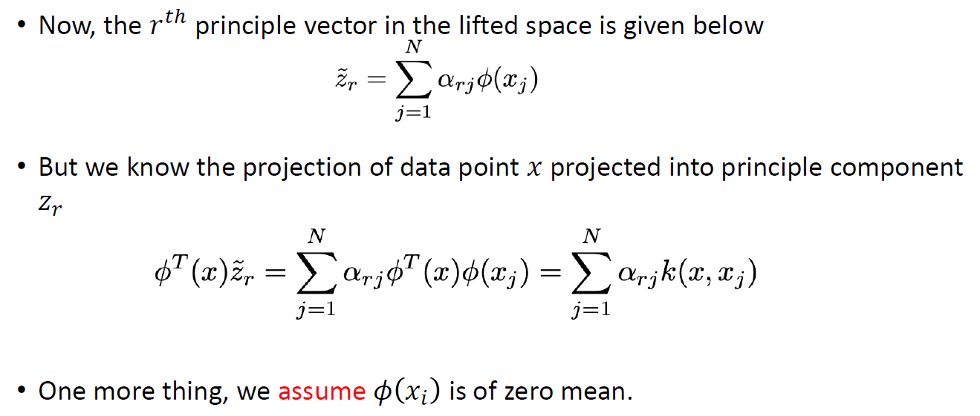

We don’t have to define φ function because it can be replaced by kernel function after several operations. Finally we can have

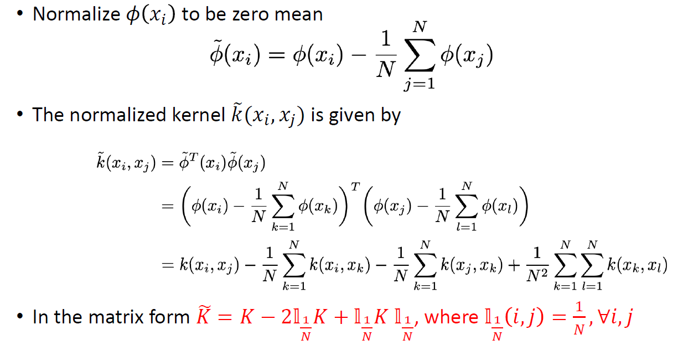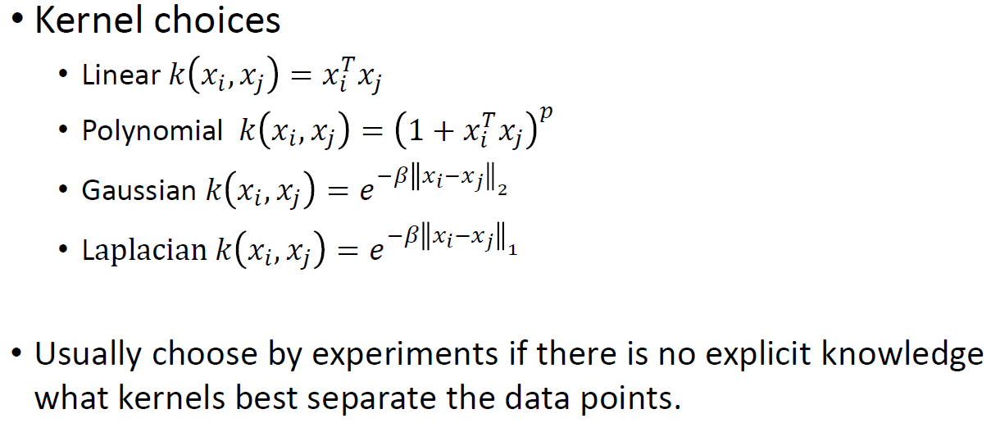

1. Kernel PCA summary:

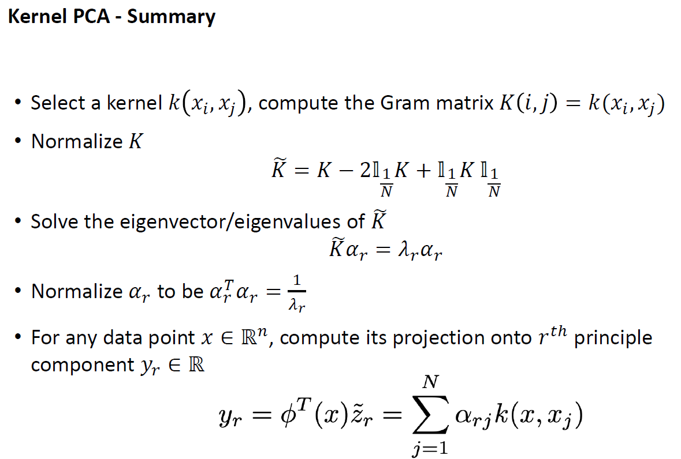

Kernel trick: convert high dimension computation to low dimension kernel function computation

**Surface Normal**

1. Find normal: fit a surface, find it tangent plane, the vector perpendicular to this plane.
2. Application in autonomous driving: detect ground. If the normal faces up, that could be ground.
3. Compute surface normal: least significant vector, that is the one with minimum eigenvalue.

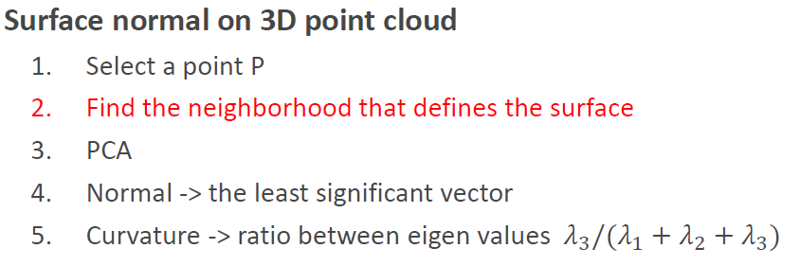

1. The reason why we want to the minimum eigenvalue direction:

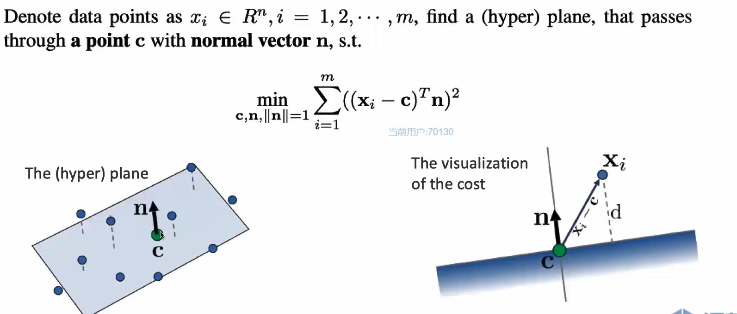 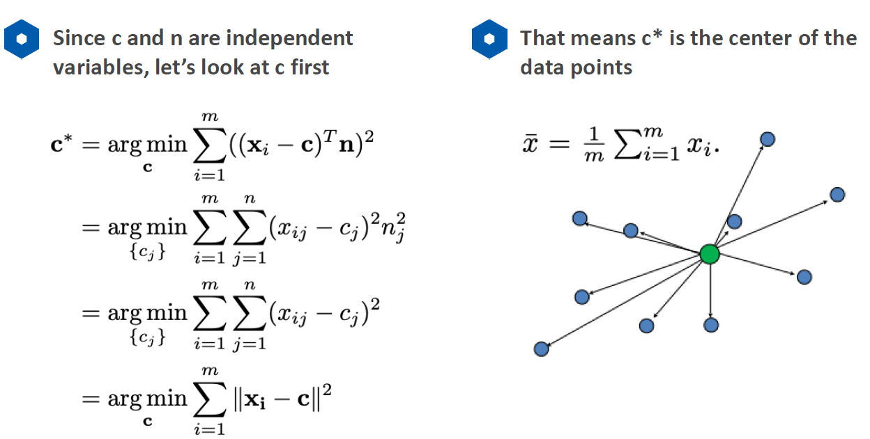

1. If noise exists in the neighbor points, how to optimize this?

Why larger radius smoother? Because the surface can includes more points which can generate a smoother average; for smaller radius, the selected surface is easier to be affected by some noisy points which will can to unstable computation of the normal.

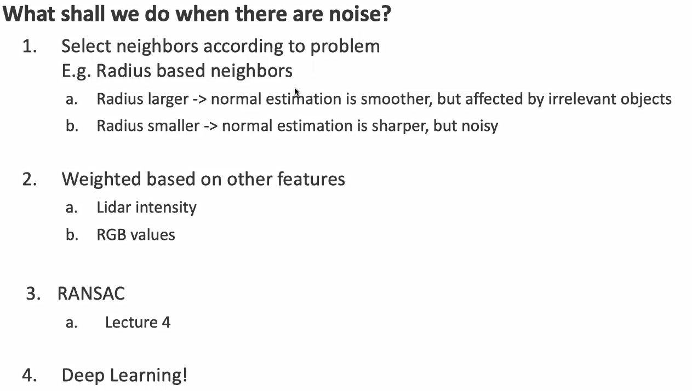

**Filters**

***Noise removal***

1. Radius outlier removal method to remove noise in the point cloud:

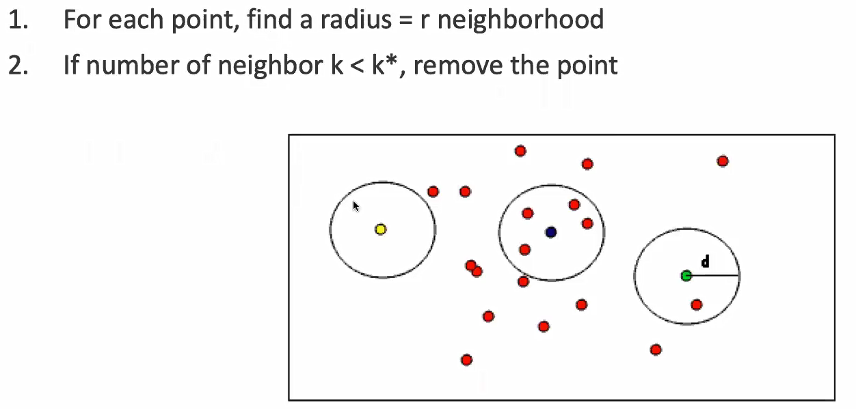

1. Statistical outlier removal: the idea is simple. Compute the distance between each point and its selected neighbors. Use these distances to build Gaussian normal distribution. Remove those points which lies in the small distribution area in the normal distribution.

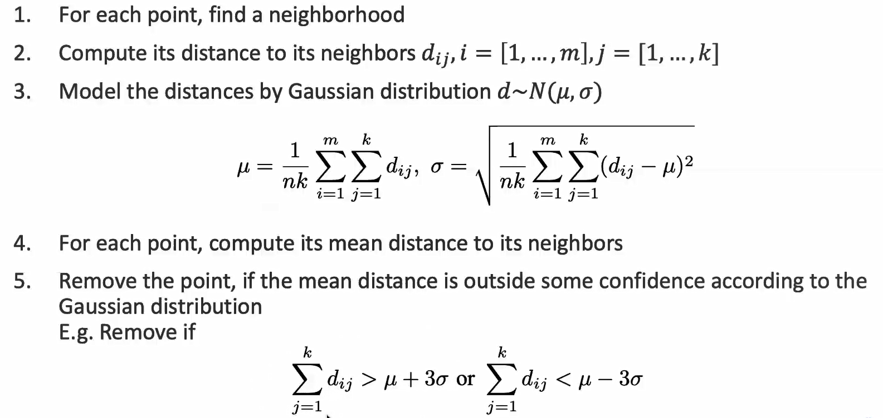

***Down-sampling***

1. Voxel grid down-sampling:

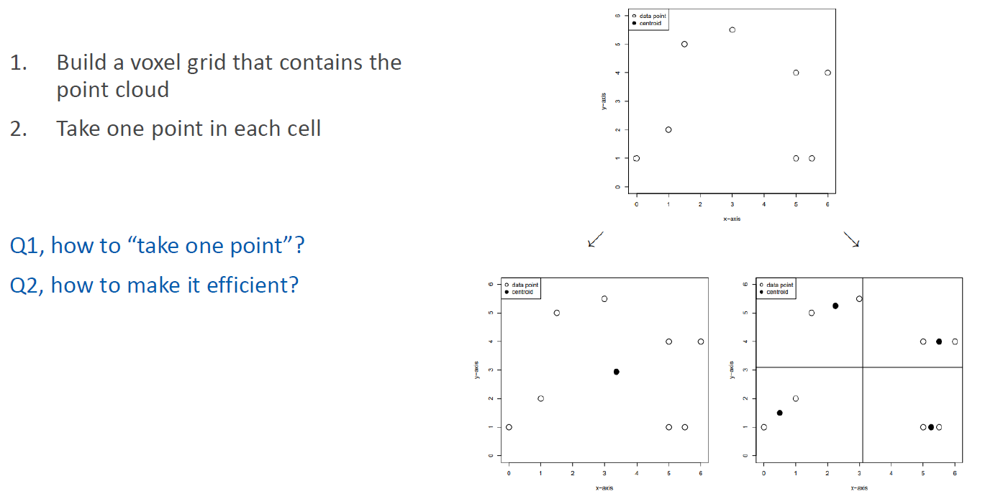 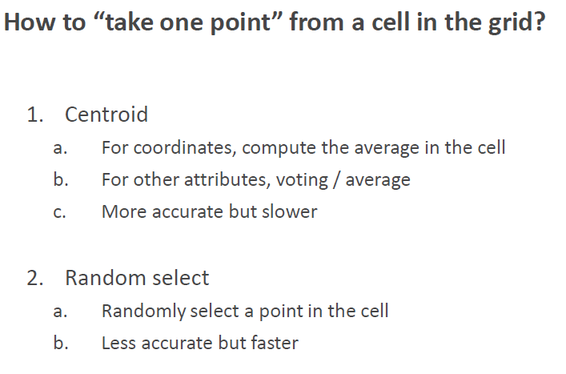

1. Voxel grid down-sampling process:

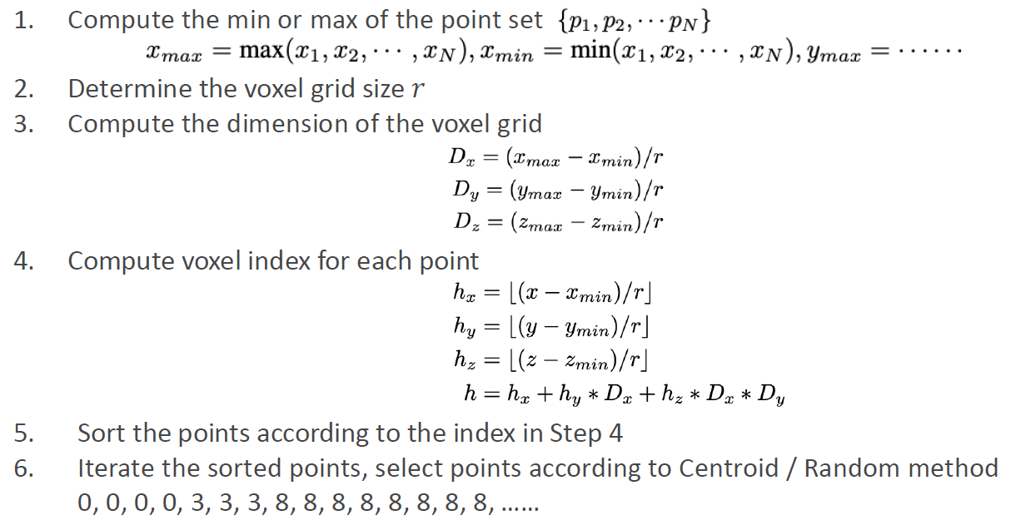

1. Voxel grid down-sampling is possible to unable to converge if the radisu is set too small.

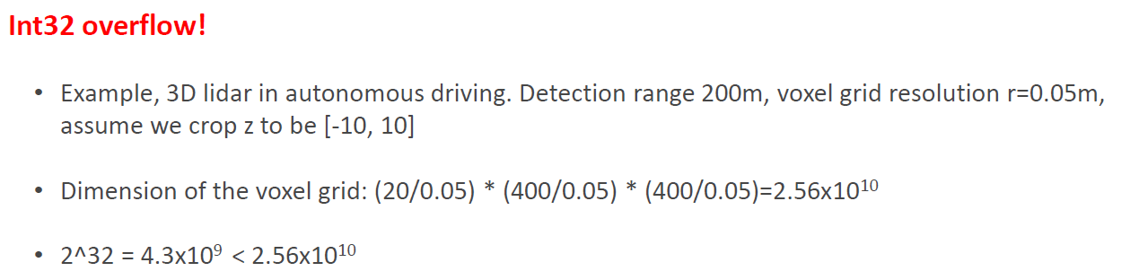

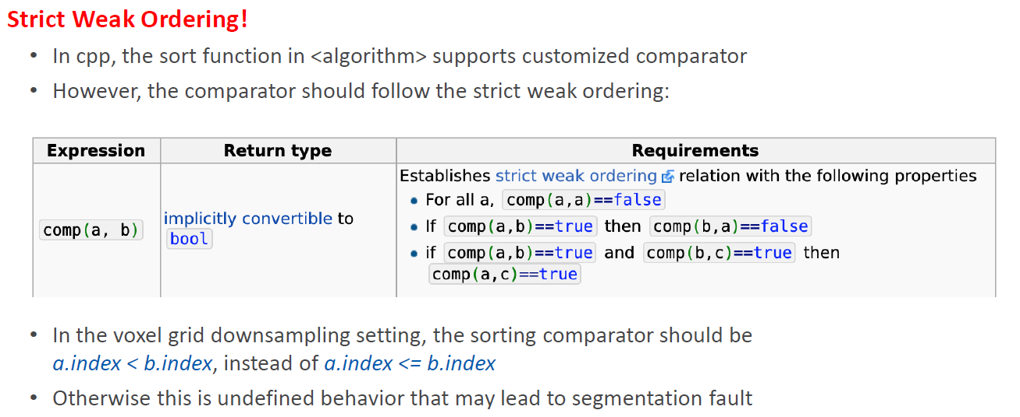

1. Since the amout of point cloud is huge, it takes long time to sort the results each time. Considering the sparse characteristic of point cloud, where most of space does not have points. We can use hash table to divide the point cloud to certain amount of buckets in hash table.

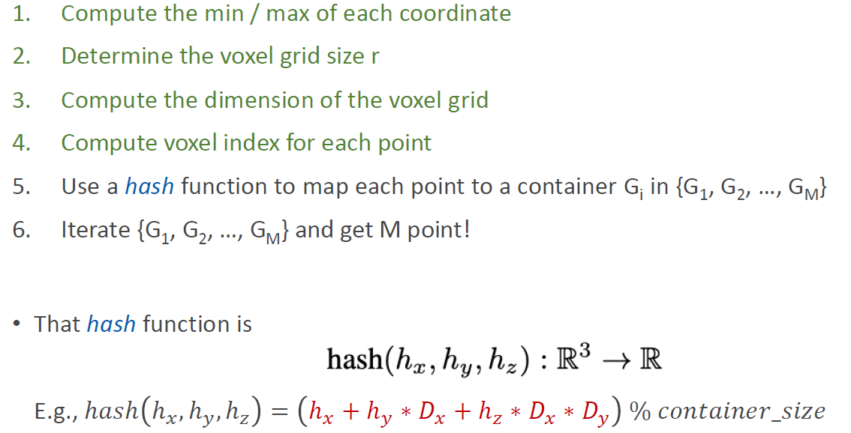

1. Conflict in hash table. When detecting conflict, we only select a point from the current container, and then empty the container.

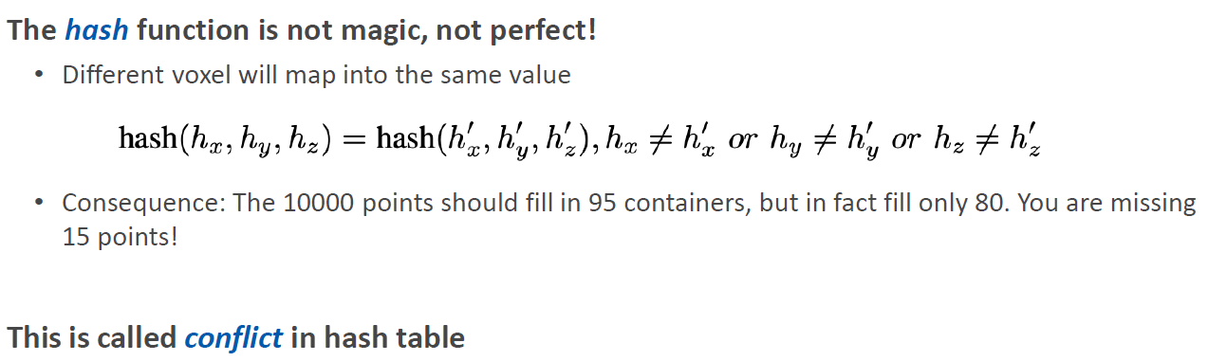 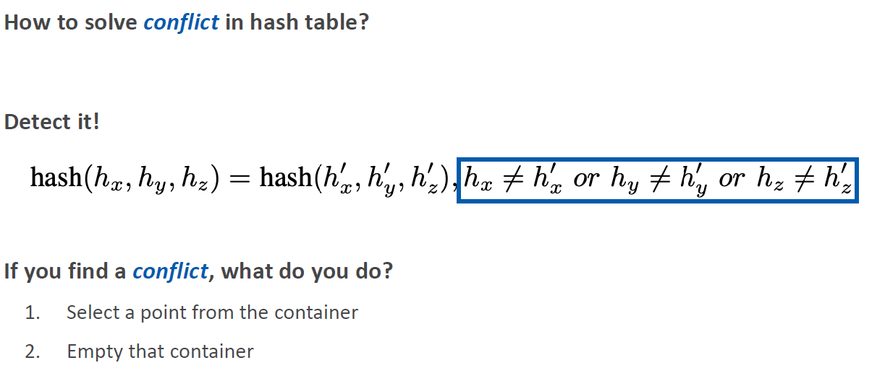

1. FPS, first randomly pick a point, then iteratively pick the farthest point.

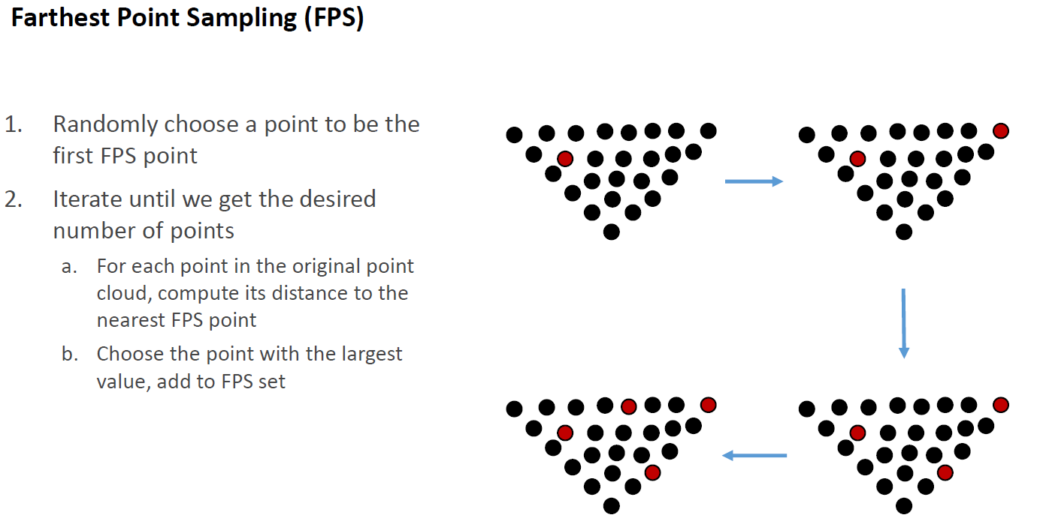

1. NSS

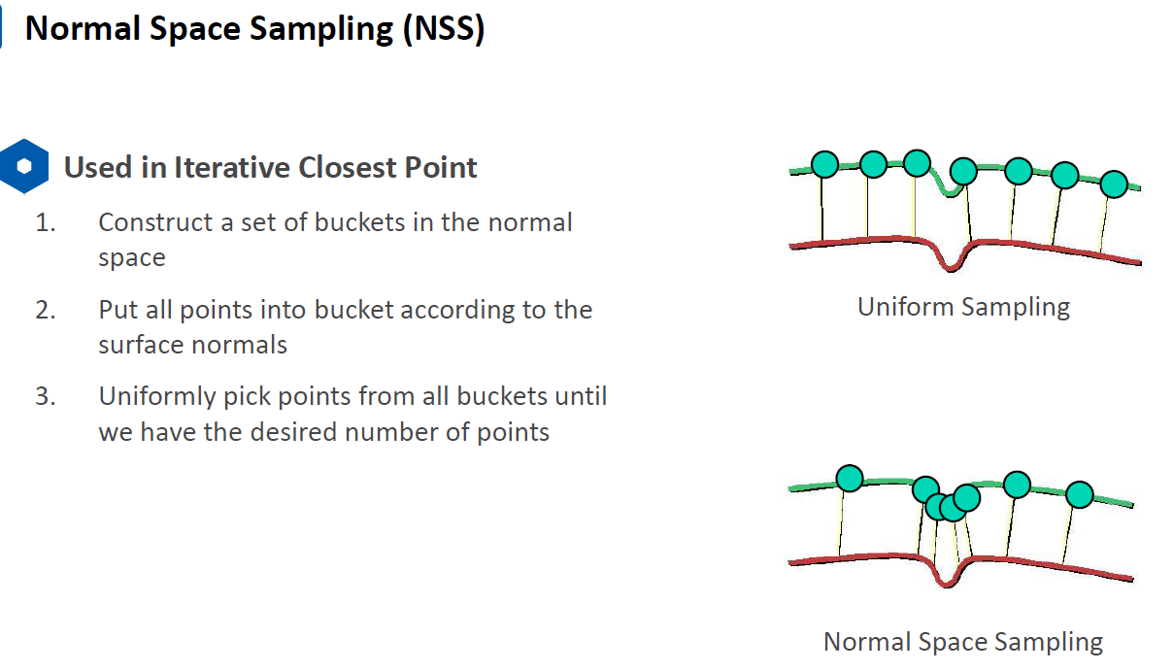

1. Up-sampling

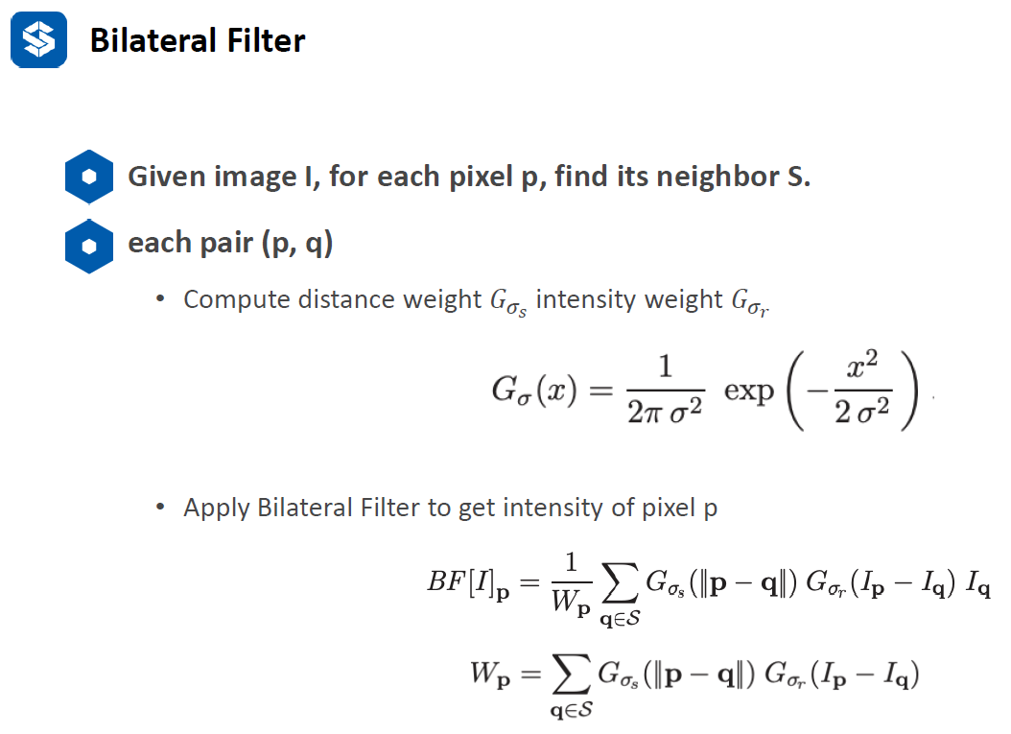

**Lecture 3**

1. Clustering:

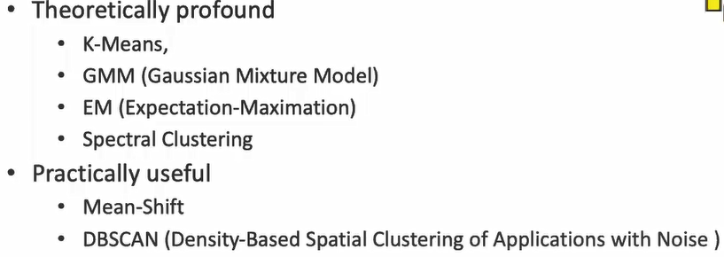

1. Directed graph modeling

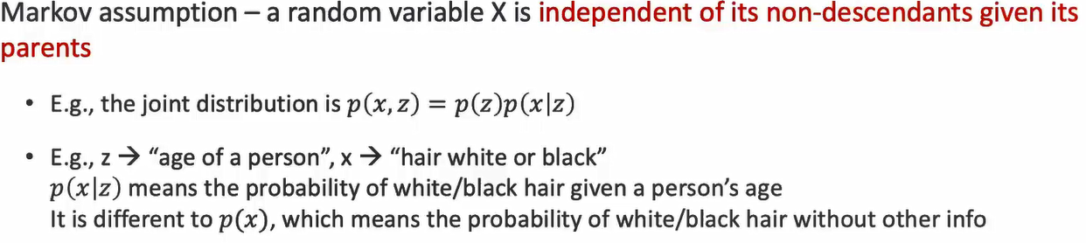

**Lecture 2**

1. Octree is designed for 3D data.
2. Benefit of octree: stop the search in advance. Because in kd-tree, we need to go up to root node to see whether we should search in the other side. This cannot be realized in kd-tree because each kd-tree level node only includes one dimension, and you don’t know how the splitting is in the previous level. Therefore, only with one dimension data, it is not enough to stop the search in advance.
3. kd-tree: kd-tree is a binary tree where each leaf node is a k-dimensional point. run binary search tree in each dimension to form the kd-tree.
4. Min_extent: the minimum edge for the octant. When the edge is small enough, we do not want to split the edge again. In this case, it can be used to avoid infinite splitting when there are repeated points. I.e., two points are totally overlapped, although the leaf size is one, we cannot split them.

Building a kd-tree:

1. set leaf size. It the number of points < leaf size, build a leaf.
2. otherwise, split the points. How? Use a hyperplane perpendicular to the selected splitting axis to divide the points in half.
3. Recursively repeat (1) and (2) to build the whole tree

Two conventions to construct kd-tree:

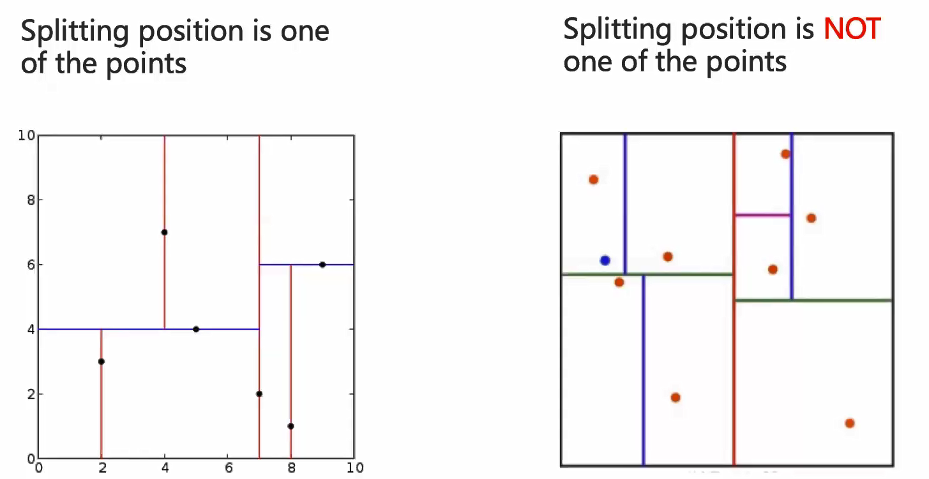 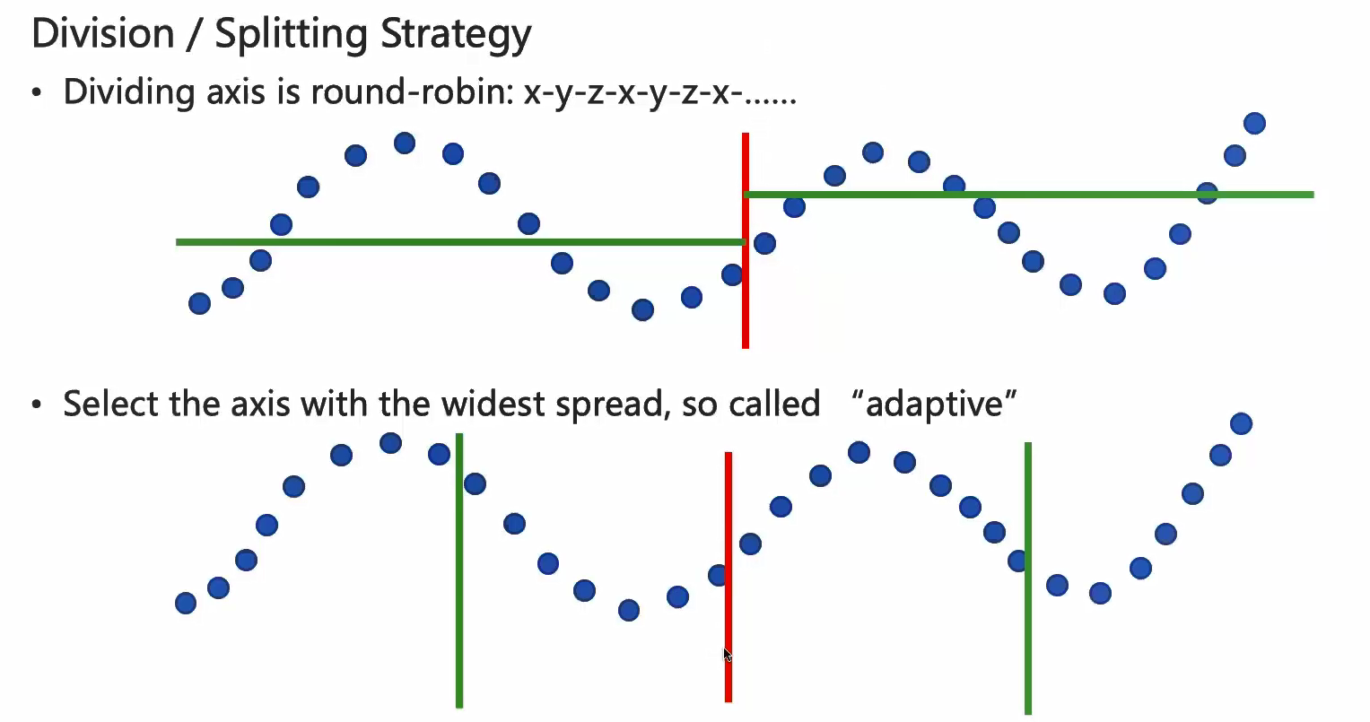

Kd-tree-KNN search:

1. Start from root.
2. Reach the leaf node that covers the query point: compare all points in the leaf node
3. Go up and traverse the tree.

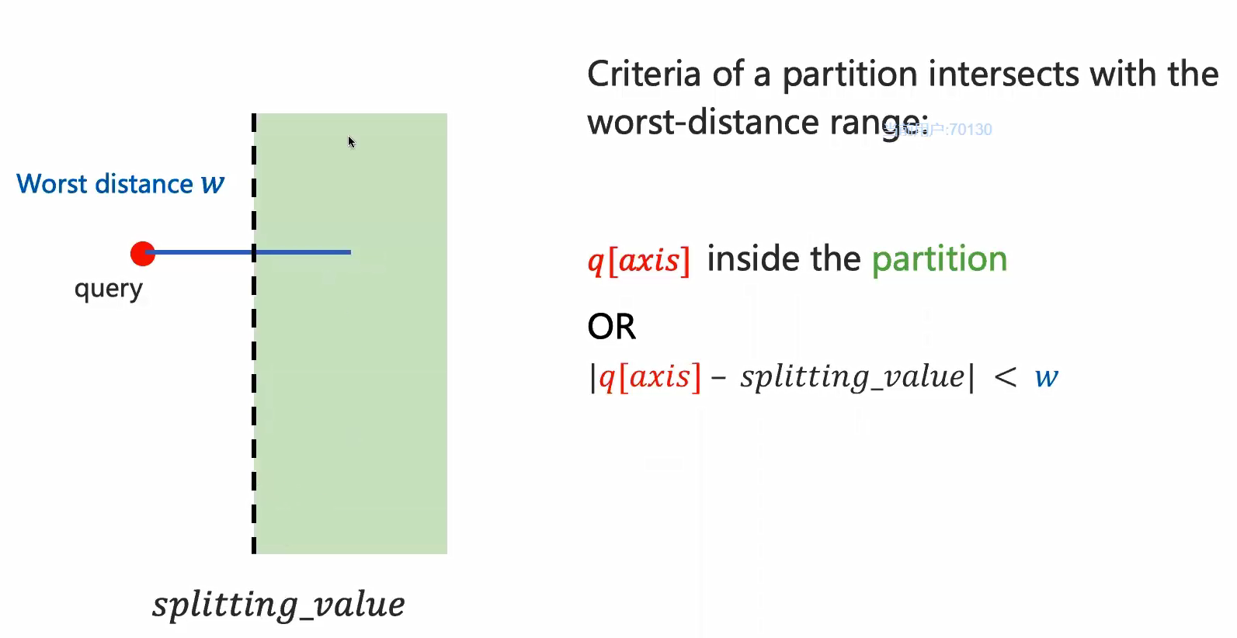

The difference between KNN search and Radius search:

In KNN, the worst distance keep updating. In Radius search, the worst distance is fixed and not changed.

**Lecture 3 clustering**

**0. Math Prerequisite:**

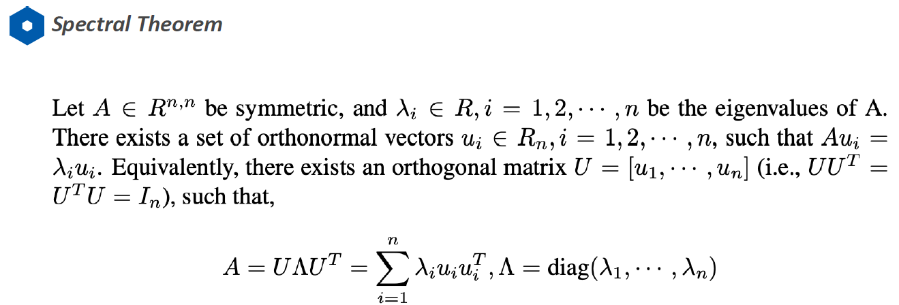 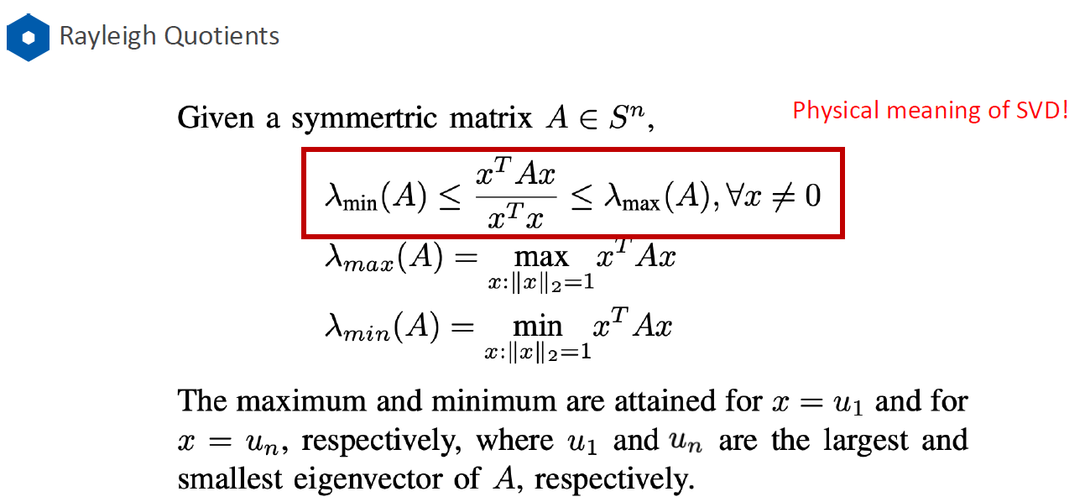

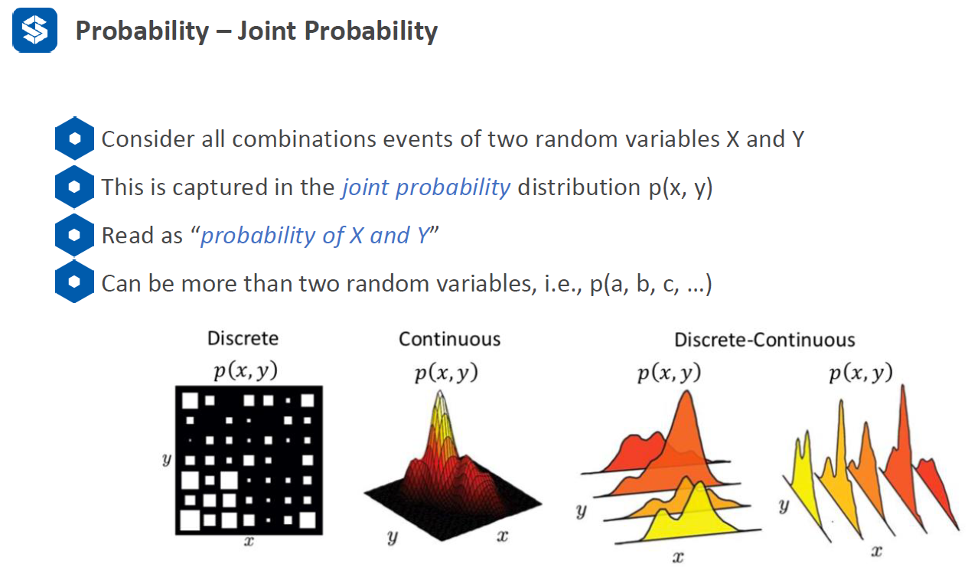 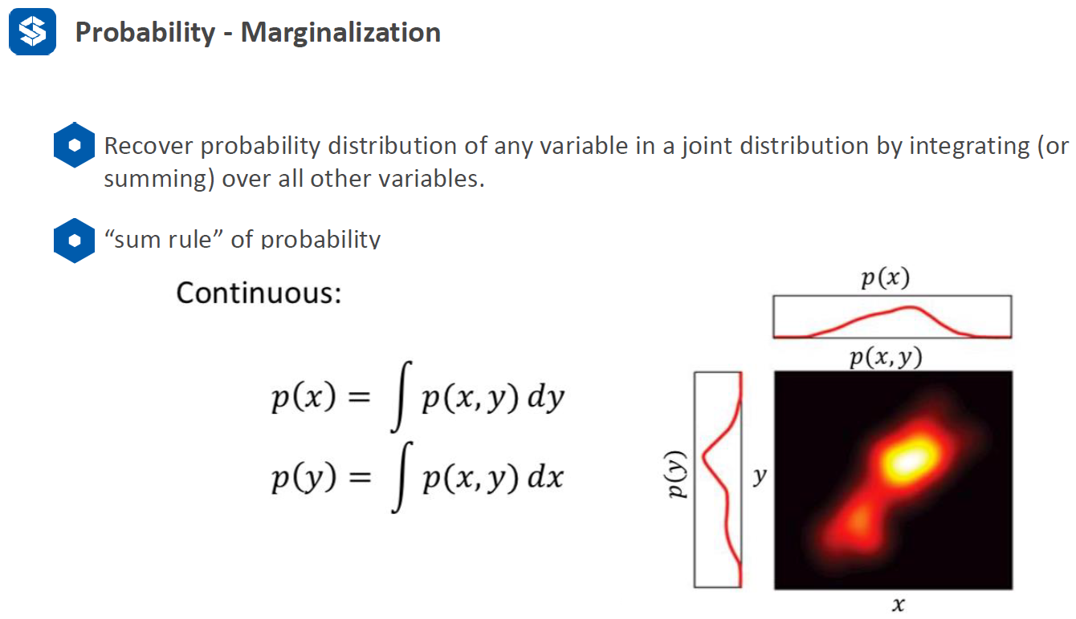

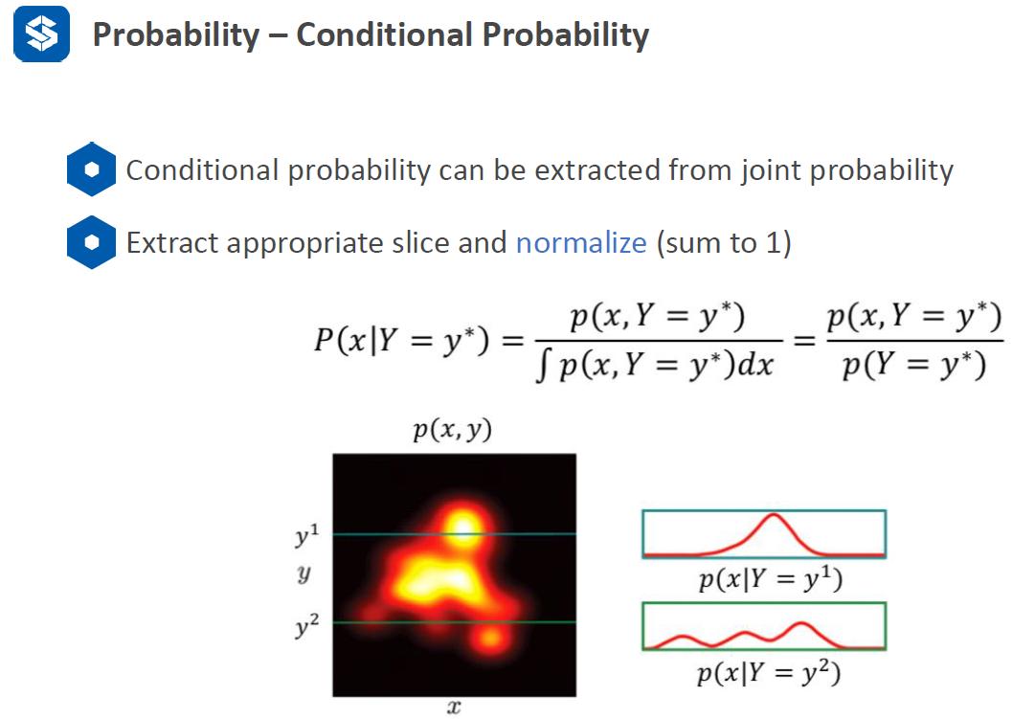 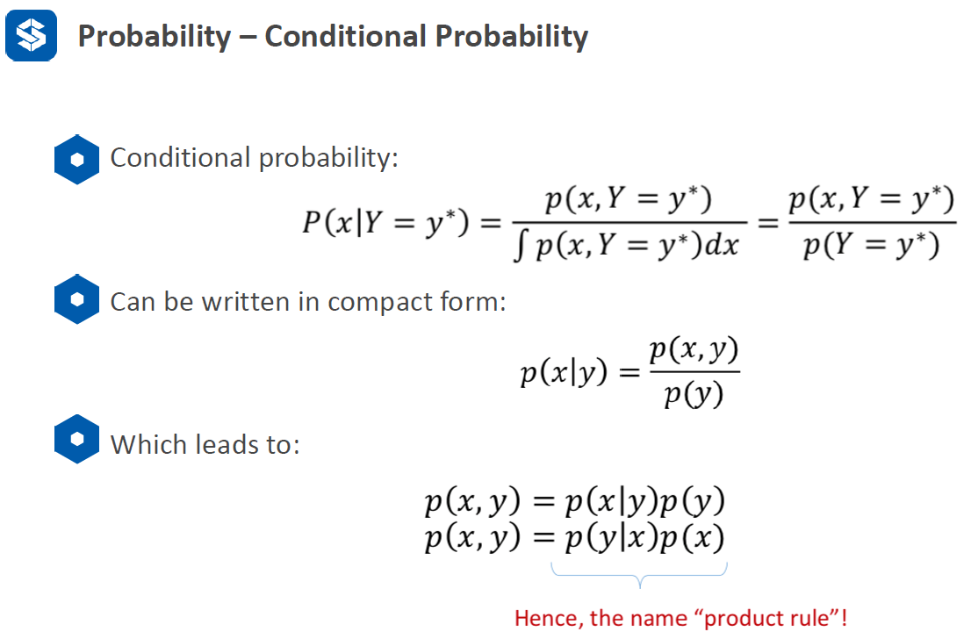

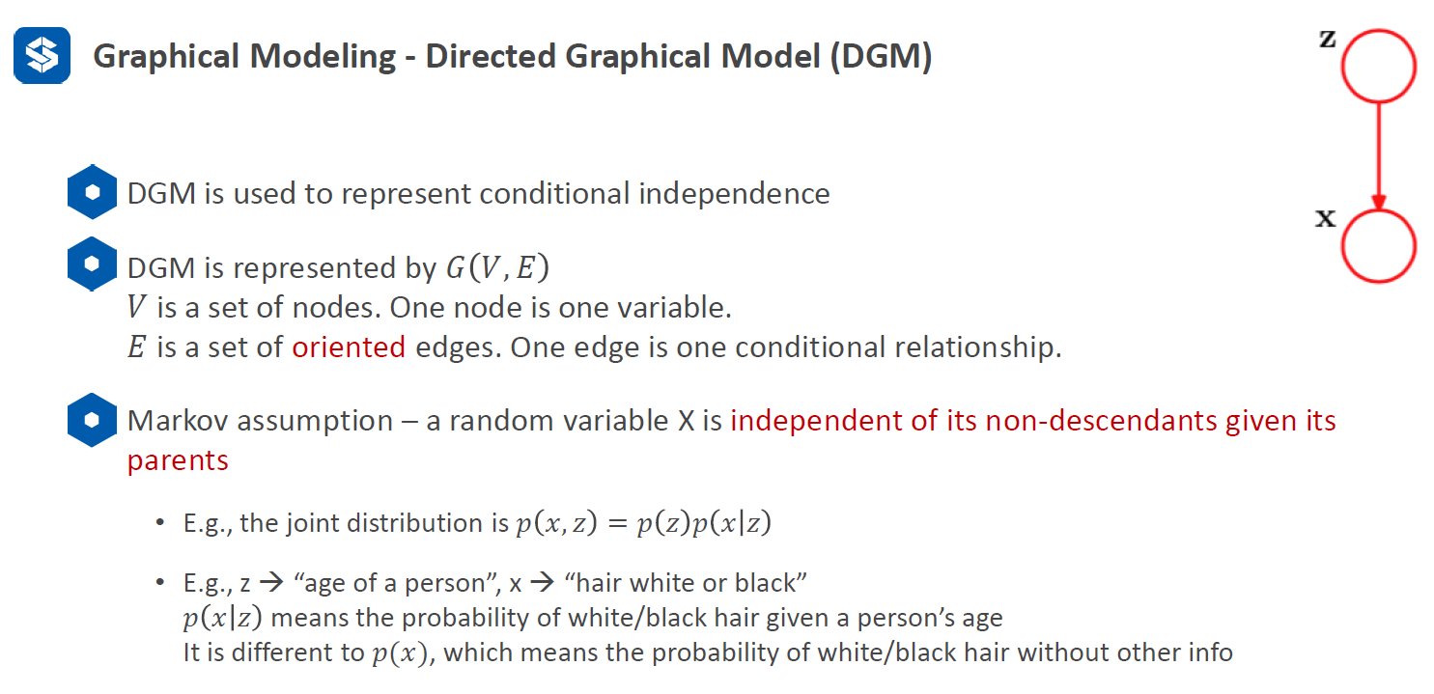 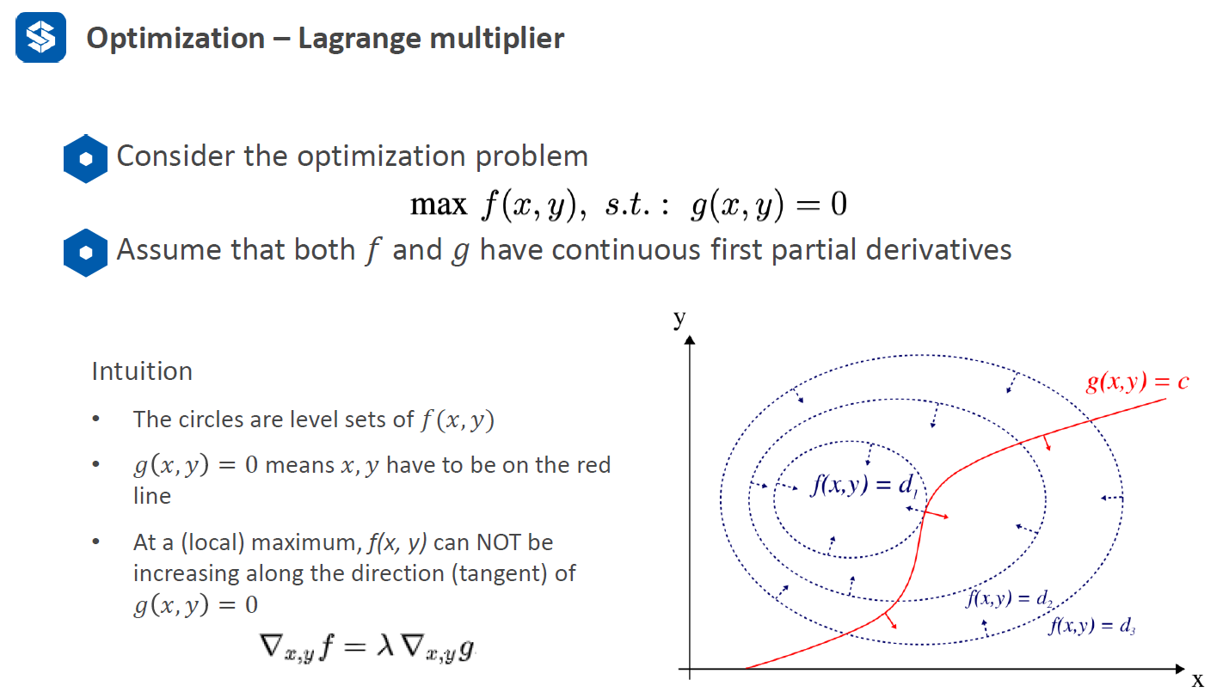

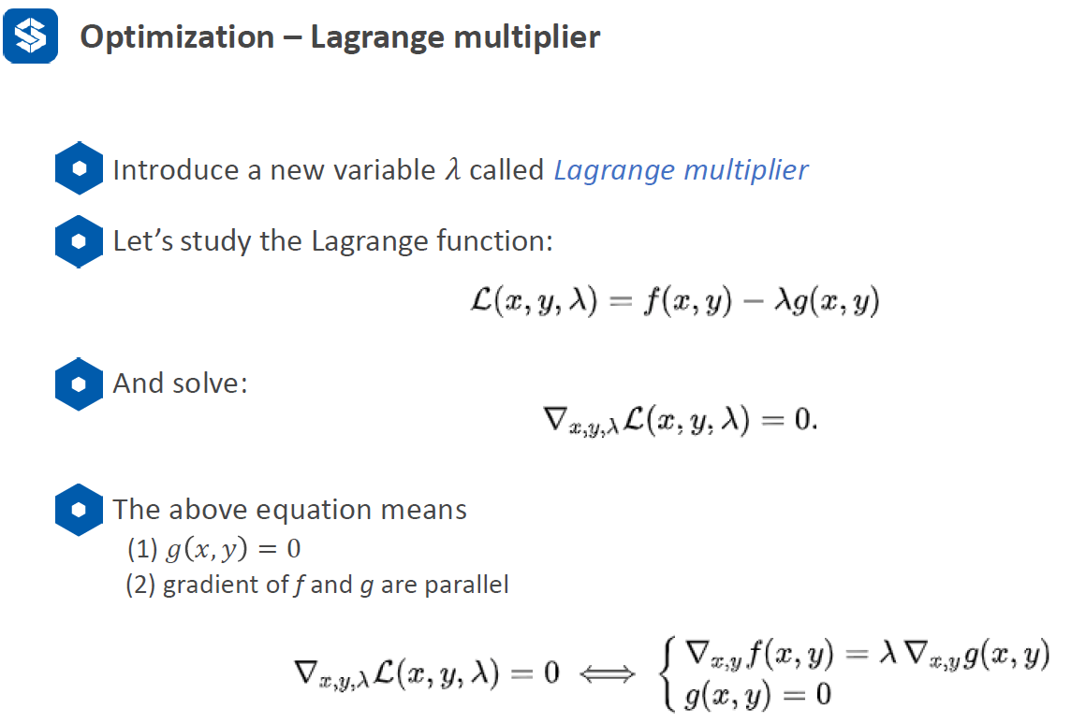

Lagrange multiplier: compute maximum f(x,y) at the constraint of g(x,y)=0. If there is no constraint, we can compute the maximum through the first derivative of f(x,y). the dash line can be represented as coutour lines of f(x,y). the tangent point between g and f would be maximal. Their gradients are parallel.

**1. K-Means**: N input data points, find K clusters.

**Process**:

(1) randomly select k center points.

(2) each data point is assigned to one of the K centers. How to assign? traverse all the points and assign them one by one over K?

A: expectation step in EM algorithm. In N points, find nearest neighbor to K centers.

(3) re-compute the K centers by the mean of each group? Do we need to have a data structure to store each cluster?

(4) iterate step (2) and (3), how many iterations is enough for convergence? What is criteria to determine it is converged?

A: the centers of the clusters are no longer changed; all the rnk are no longer change. Generally, center and assigned points are not changed any more. Special case: it is possible that the centers of clusters back and forth, we need to consider this case carefully.

**Mathematic definition:**

rnk is used to denote xn belongs to which cluster? i.e., the nth point xn belongs to the kth cluster, rnk = 1.

Only input points are known, uk and rnk are unknown.

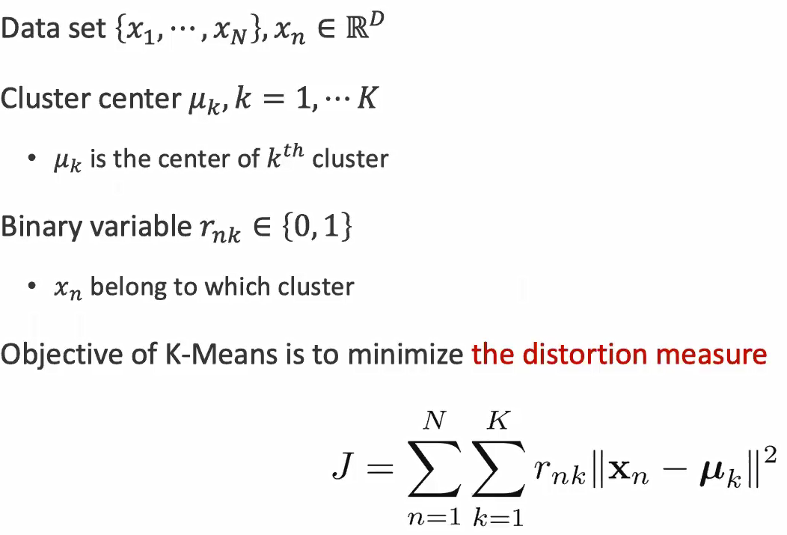 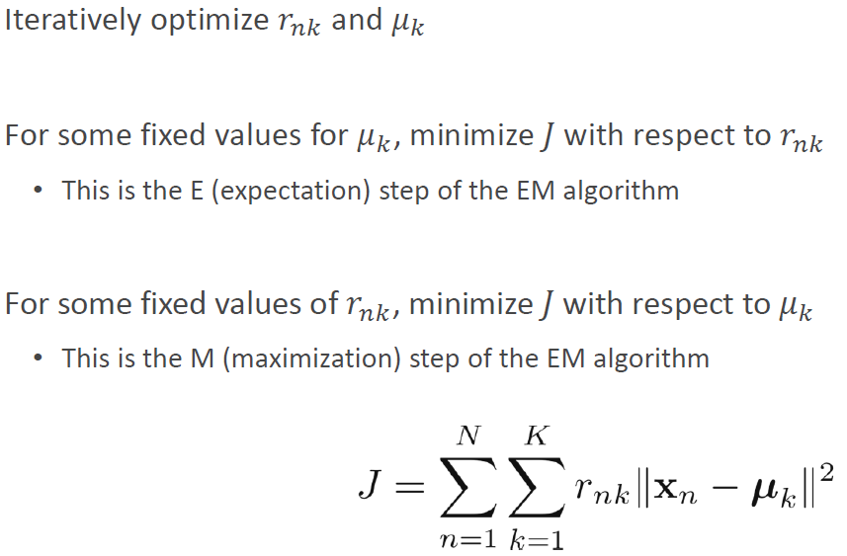

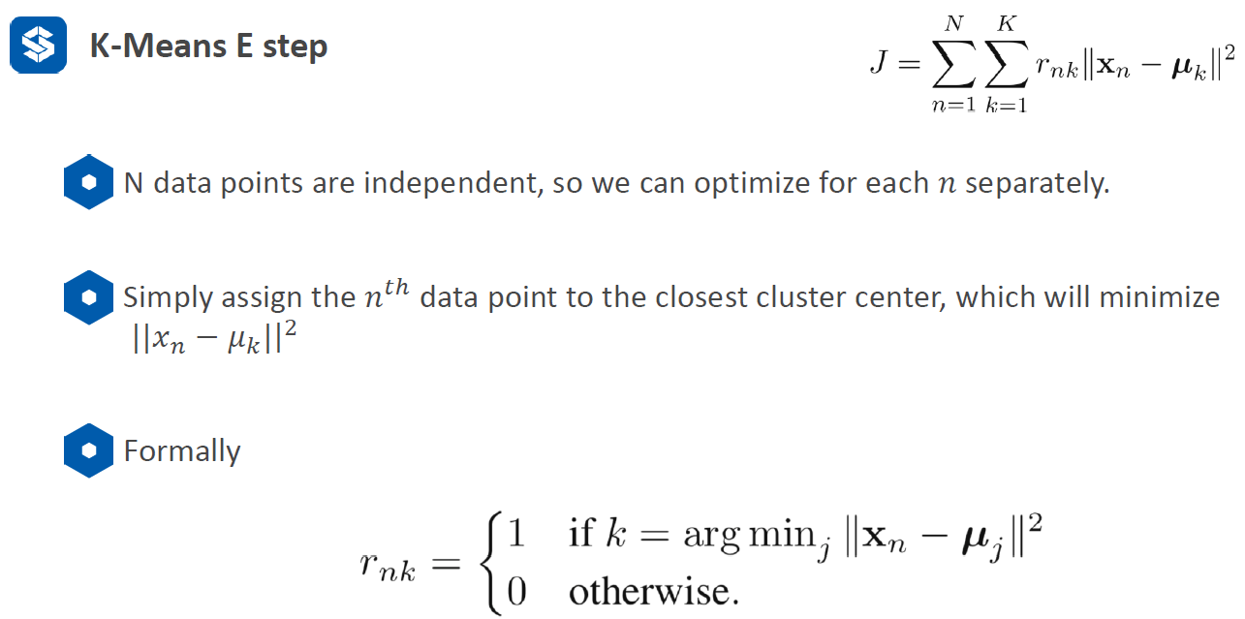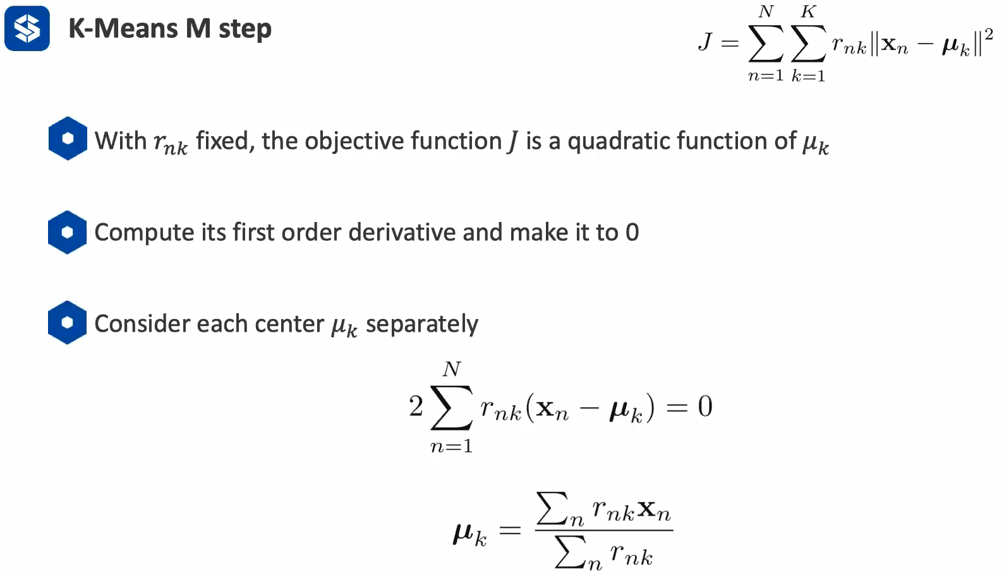

Meaning of 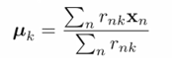: the center of a cluster equals to the mean of the points which belong to this cluster. i.e., in N points, when the points are in this cluster, rnk = 1, say this cluster has three points, then we have uk = (1*x1 + 1*x2 + 1*x3) / (1 + 1 + 1) = (x1+x2+x3)/3

**K-Means Practical Tricks**:

(1) K random points should be selected from the input points instead of random point in the space.

(2) K-Means is affected by initialization. Normally we will run several times and pick the one with minimum cost.

(3) E-step: we need to the nearest neighbors from N points to K centers. We can use KD-tree to make the process faster.

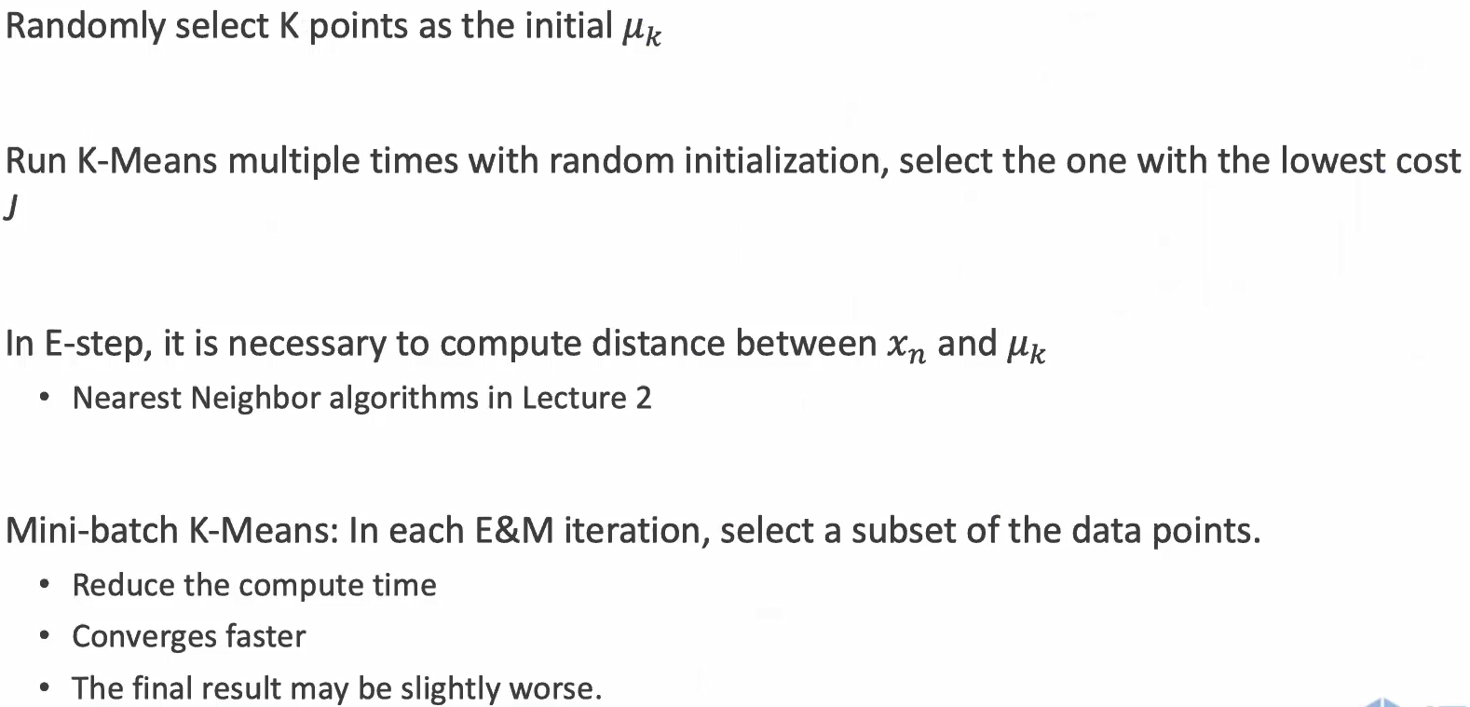 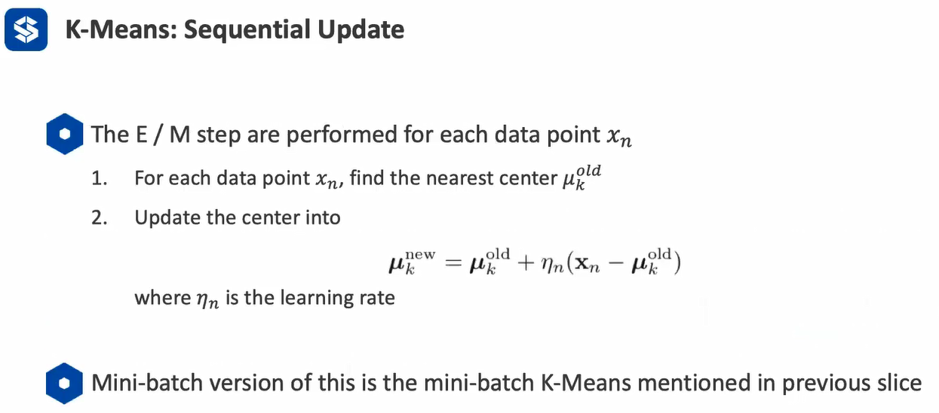

**K-Medoids: enhaced K-Means**

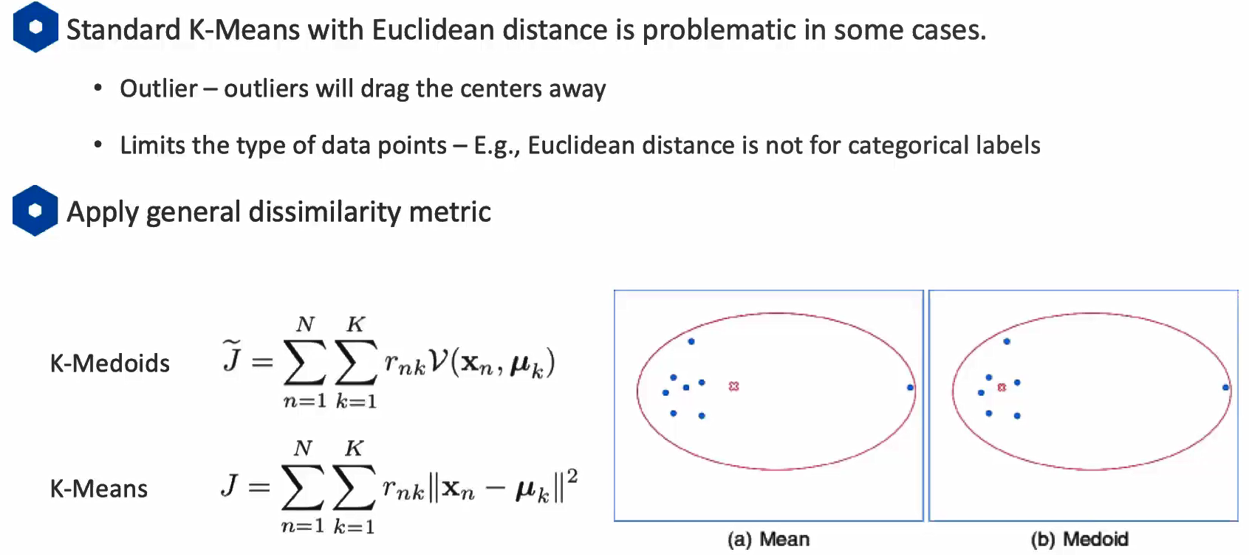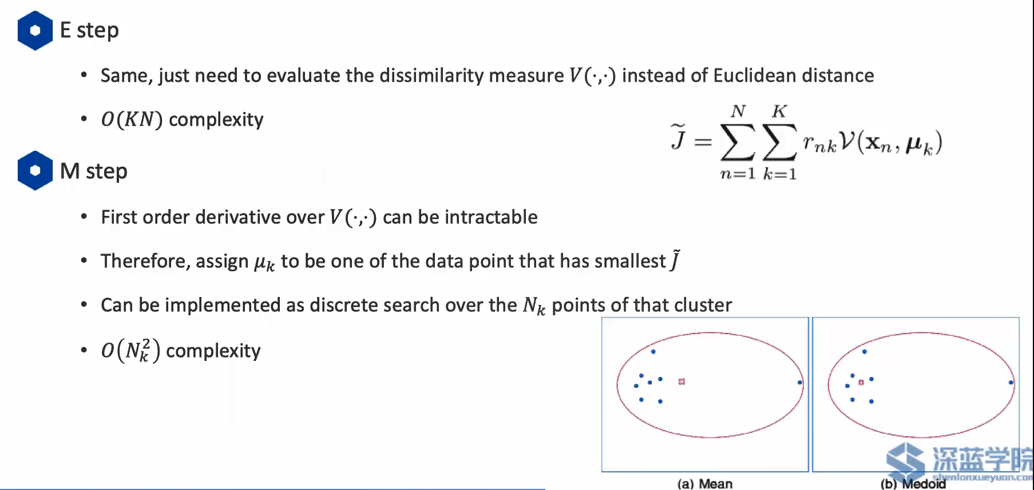

Why time complexity is O(n^2) ? i.e., to find the medoids, we need to traverse the distance of each to all the other points, and select the one with minimum distance sum.

**K-Means Application-compression**

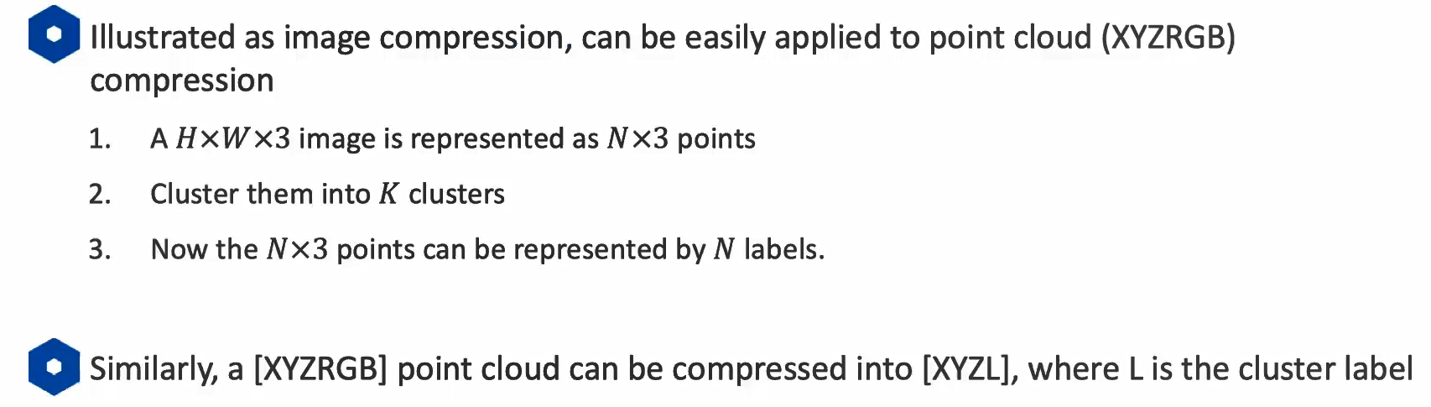

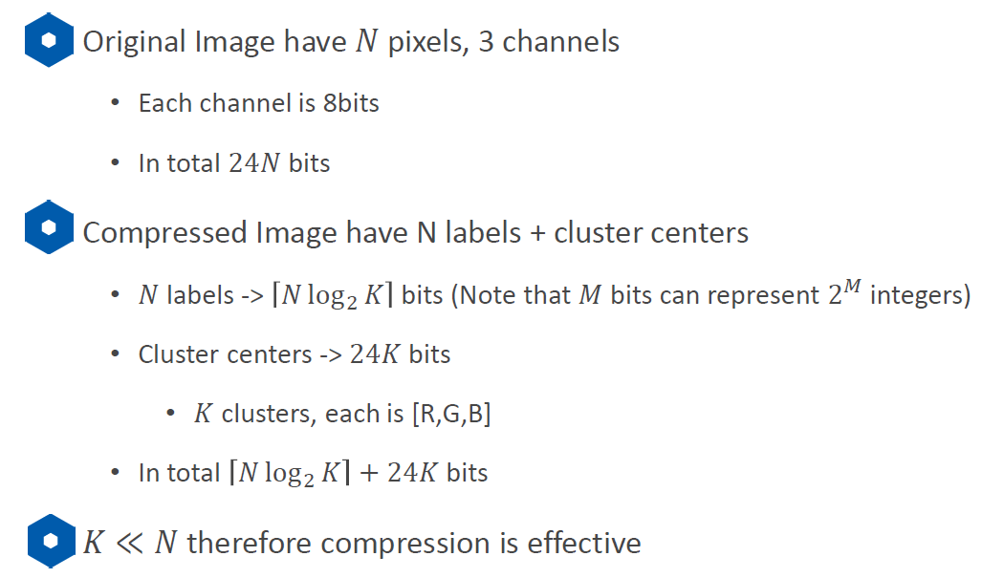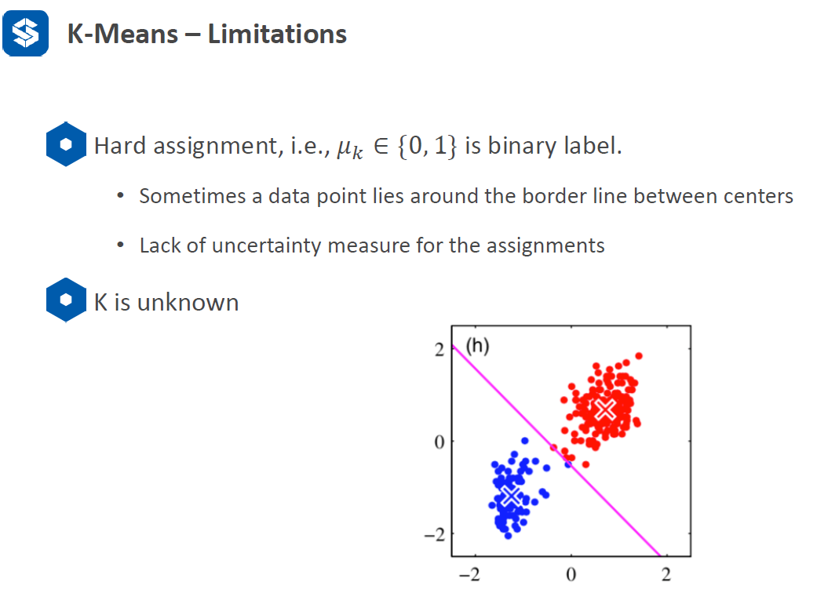

(1) Point cloud can only be compressed for color data instead of coordinates data.

(2) K-Means can only assign the points to a specific cluster, but it cannot output the probability for that cluster.

**2. Gaussian Mixture Model (GMM): represent a cluster by a Gaussian Distribution, soft assignment**

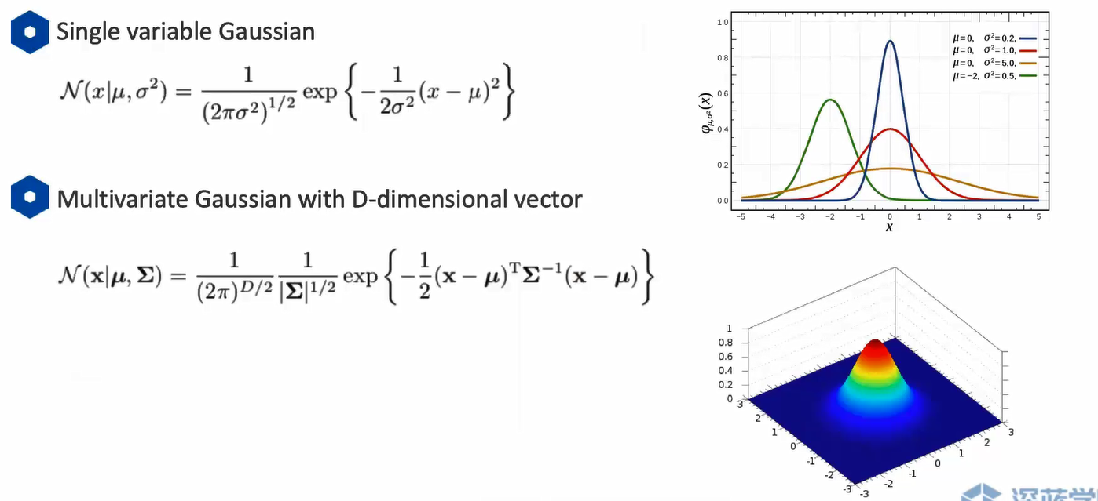

**GMM as linear combination of a single Gaussian using weights:**

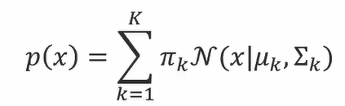**,** k is empirical. 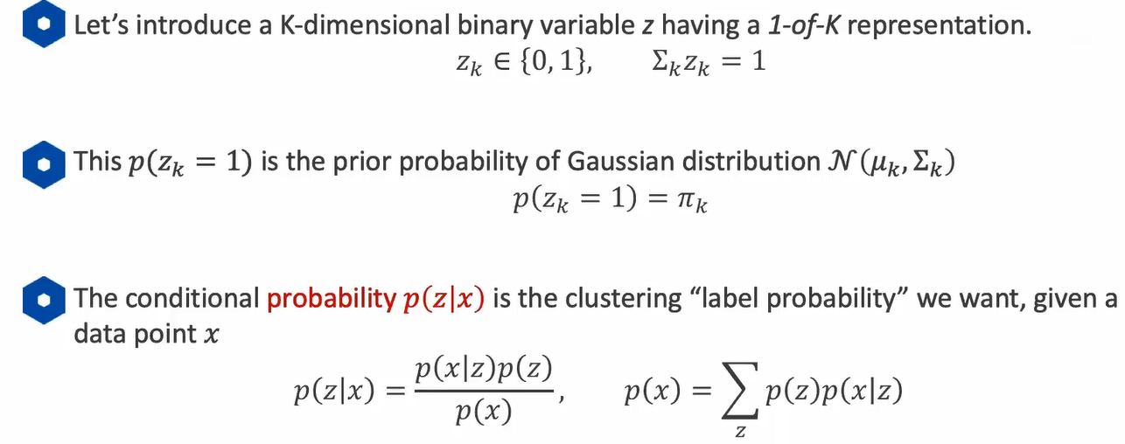

Z is similar to one-hot vector. Zk is different from rnk which does not have probability. The probability of Zk=1: we want to know the probability of a point belongs to kth cluster, but we do not have any information except for the gaussian distribution. In this sense, it is intuitive to consider the distribution with the corresponding weight, so it is the prior of gaussian distribution without any other condition. For the conditional probability given x, now we know which point is, so we can compute p(z|x) based on naïve bayes rule, which is the posterior.

The representation of graphical model:

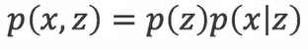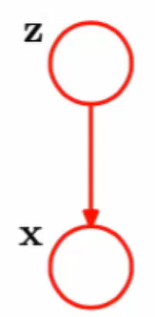, same. x is the datapoint, z is the selected gaussian distribution.

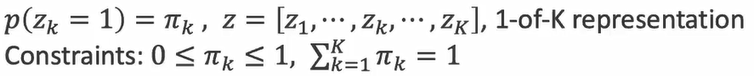🡪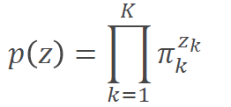

Single gaussian distribution: 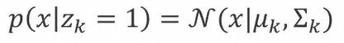🡪GMM: 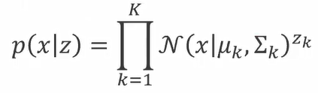

Marginal distribution of x: 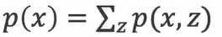🡪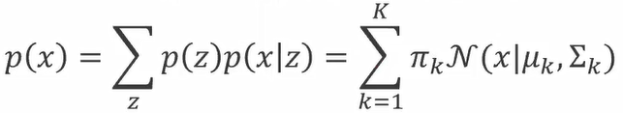

**Get posterior p(z|x)**: given data point x, which cluster it belongs to?

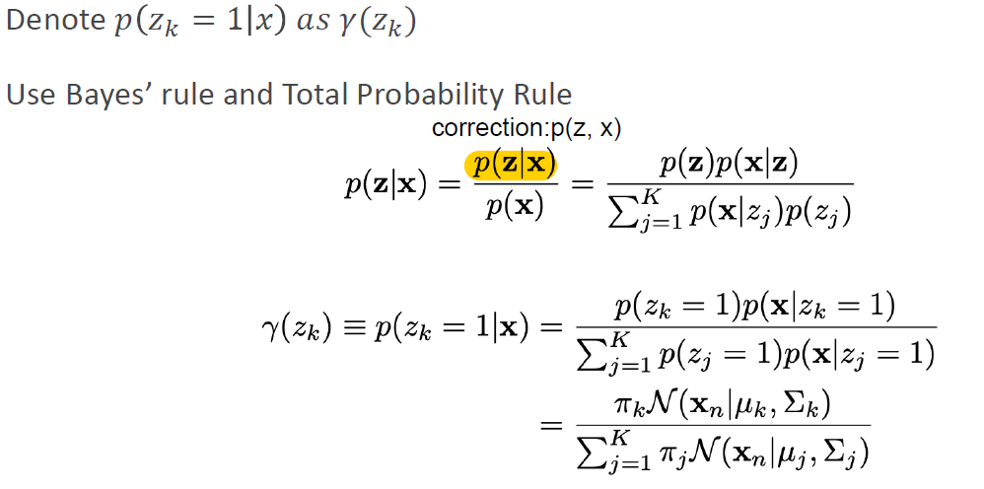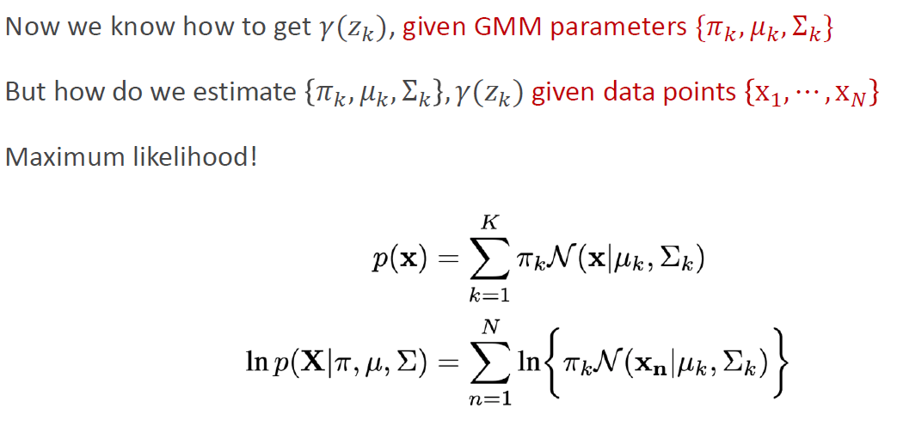

When we got this probability, how can we know which cluster it belongs to?

Why do we use maximum likelihood? Since we have several points which have their own probability, the final result is the product of these probabilities. Multiplication is not easy to process, so we use logarithm to process the multiplication and convert it to the addition process. This is the purpose to use MLE.

**Important**: GMM can suffer ***singularity*** problem when using maximum likelihood formulation

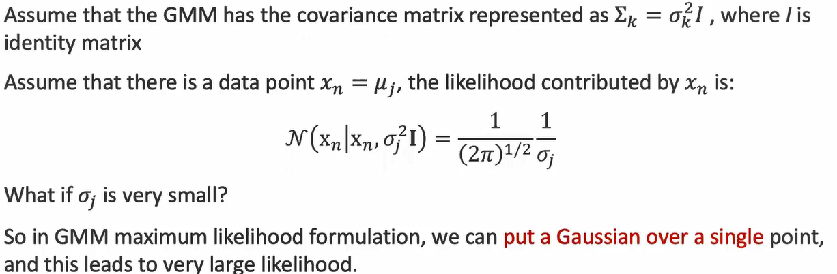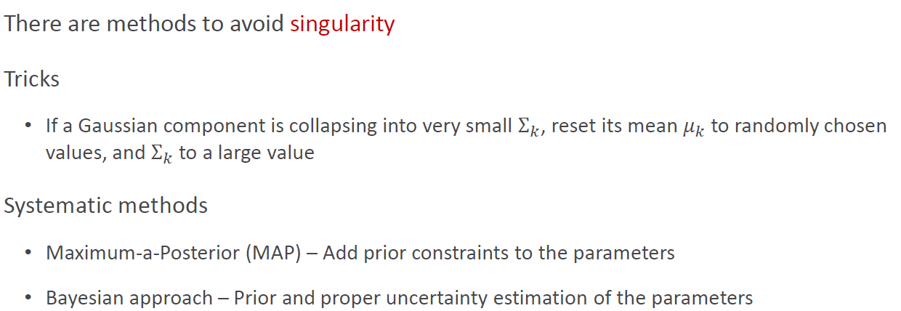

How to solve MLE?

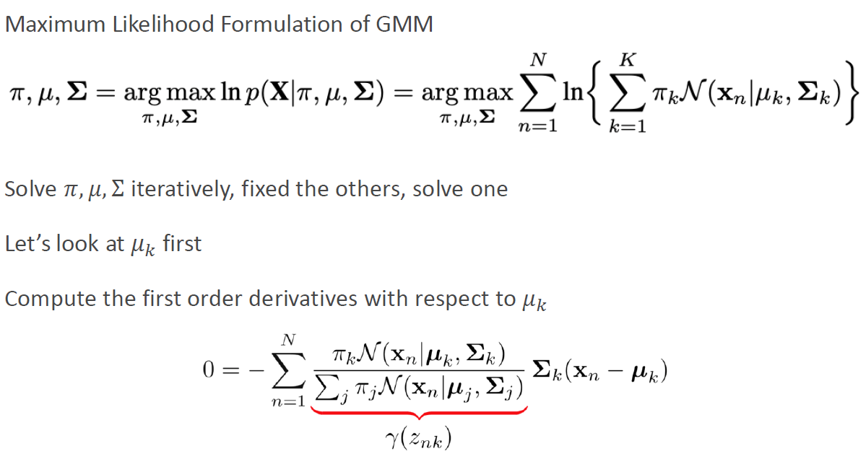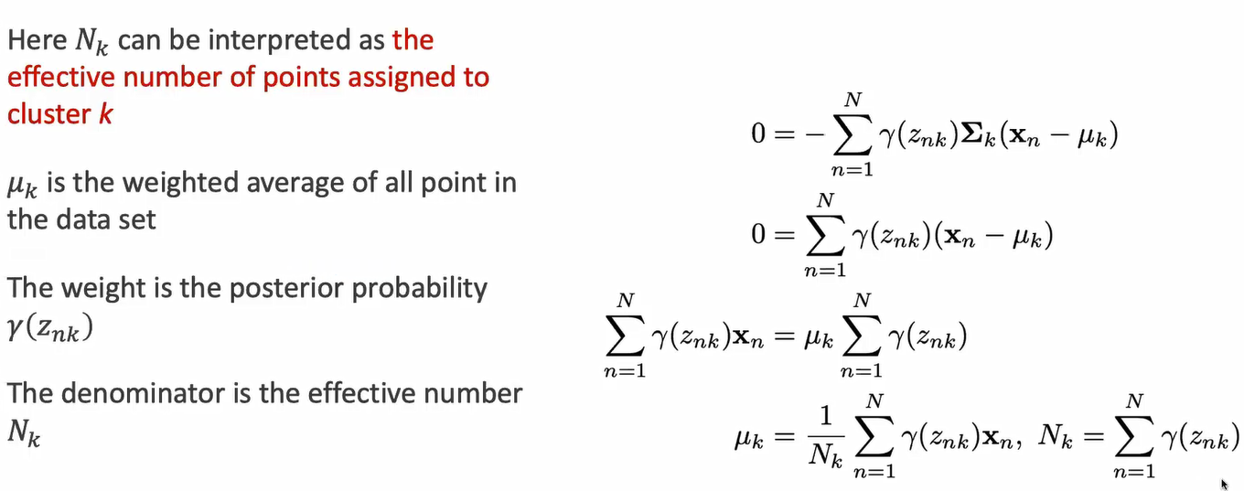

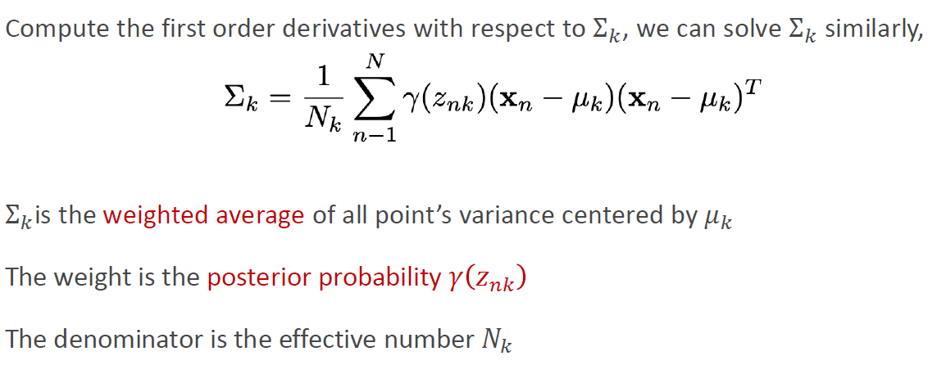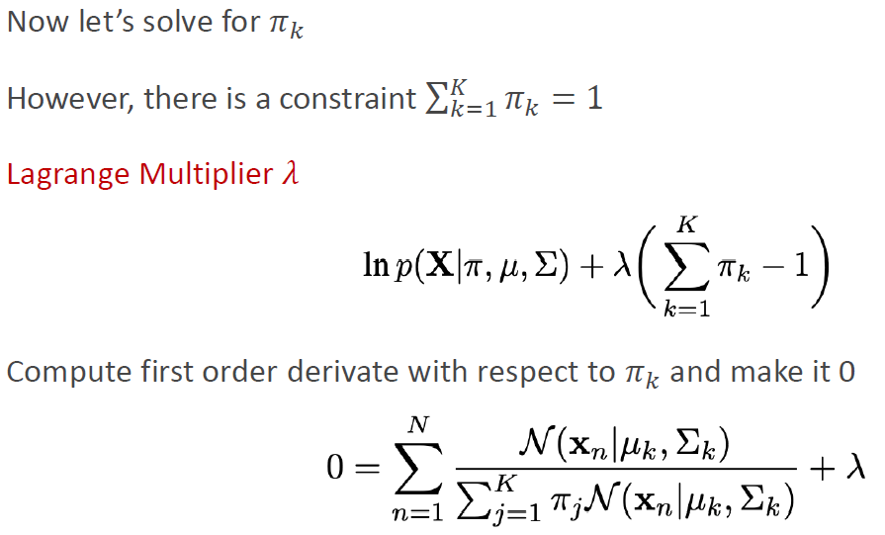

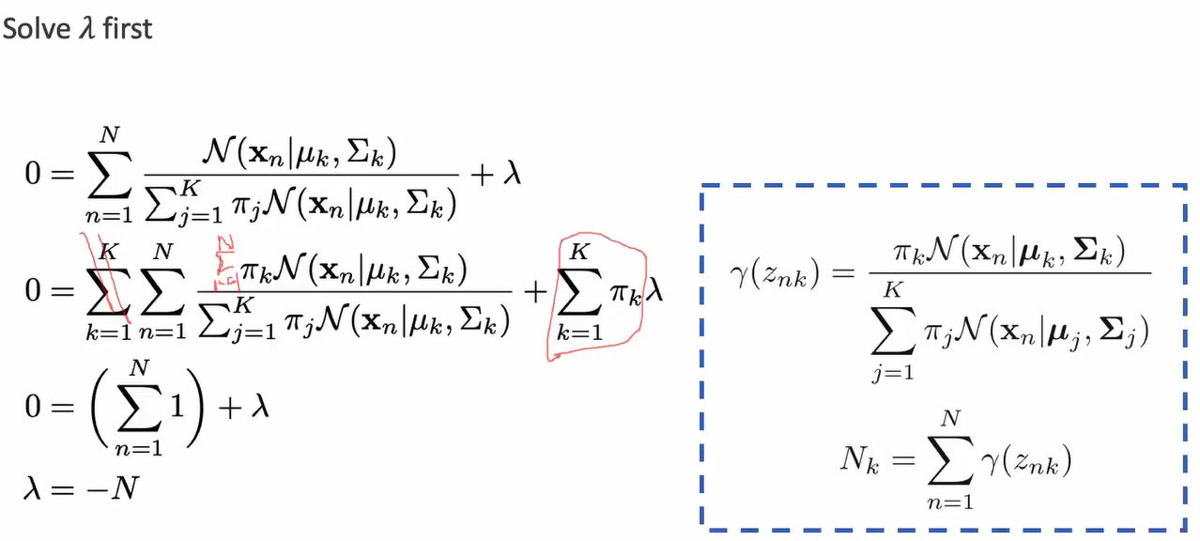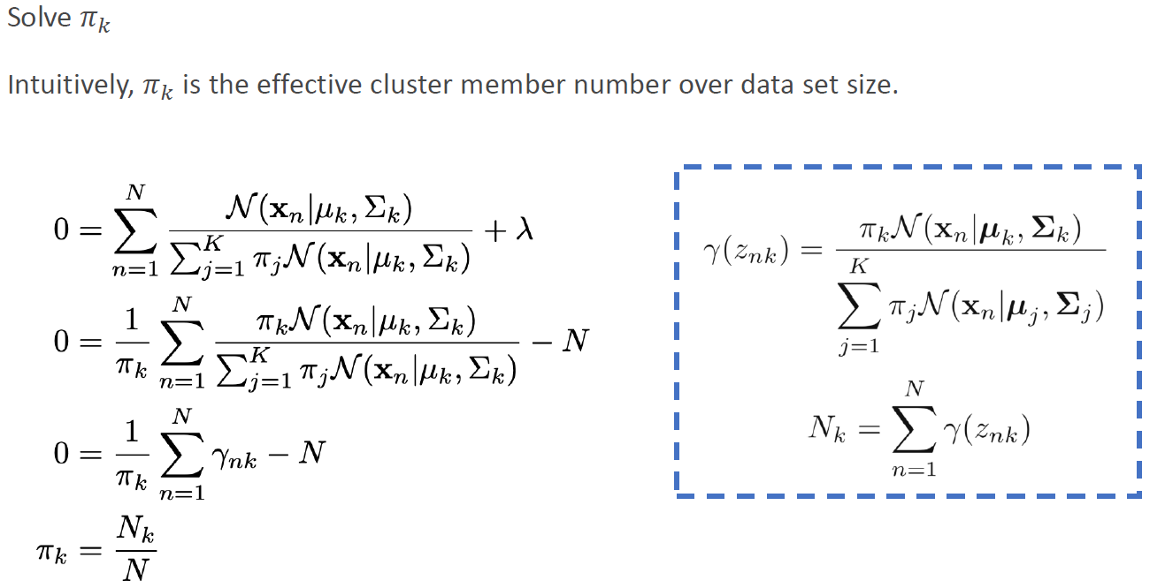

for solving pi, it has a constraint :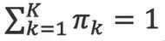. So it cannot be solved directly as the mean and variance do. To this kind of optimization problem with constraint, we can use Lagrange Multiplier to solve it.

**GMM MLE Process**:

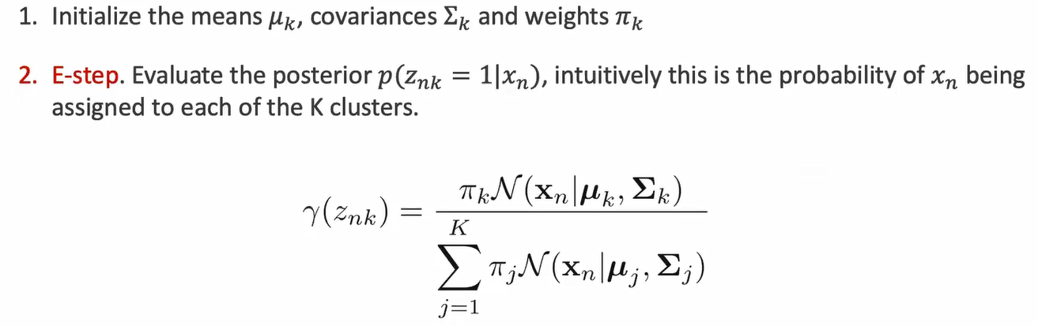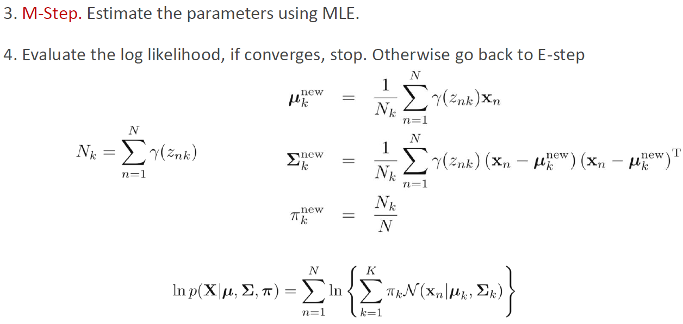

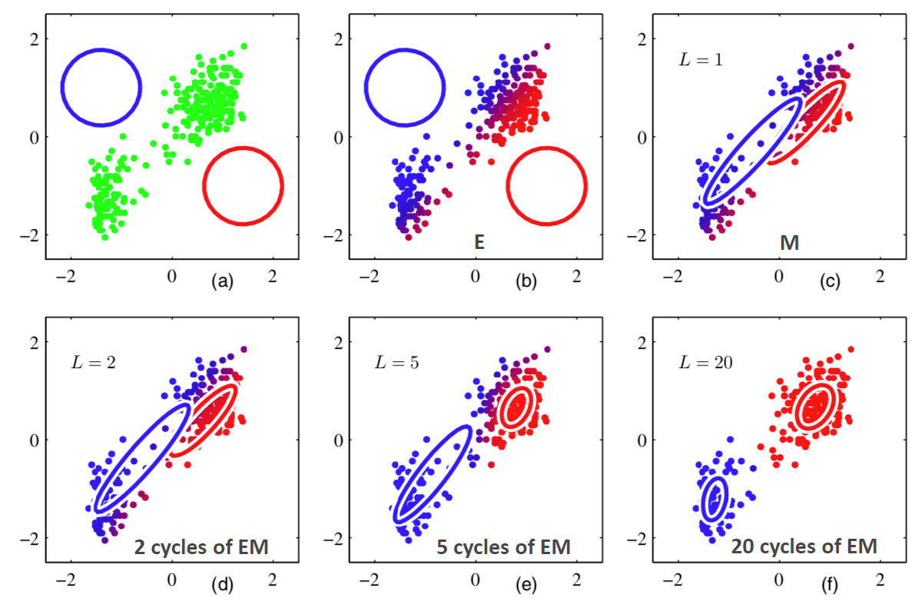

1. Initialization: center position (mean), variance, weights (0.5). We first build two circles since the variance in a circular gaussian distribution is uniform in all directions.
2. E step.
3. M step.
4. Repeat EM steps.

**Expectation-Maximization (EM)**

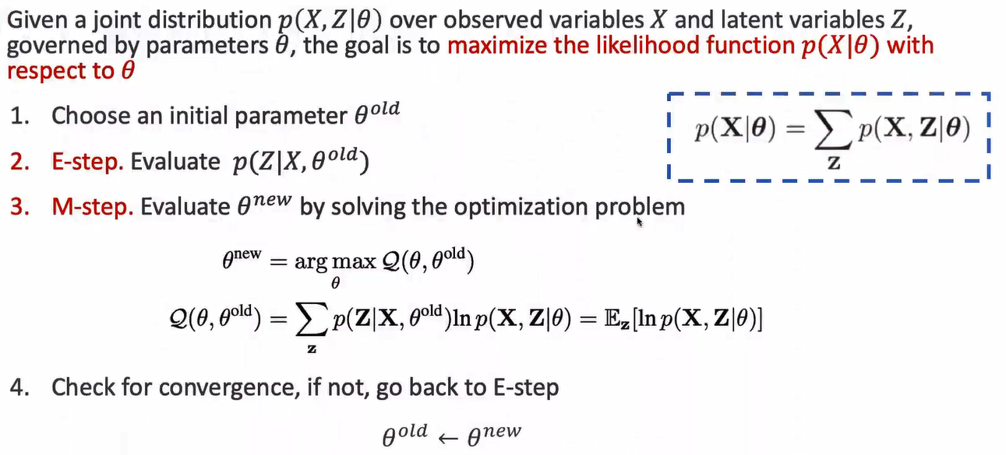

EM is a general optimization method, i.e., p(x|θ)

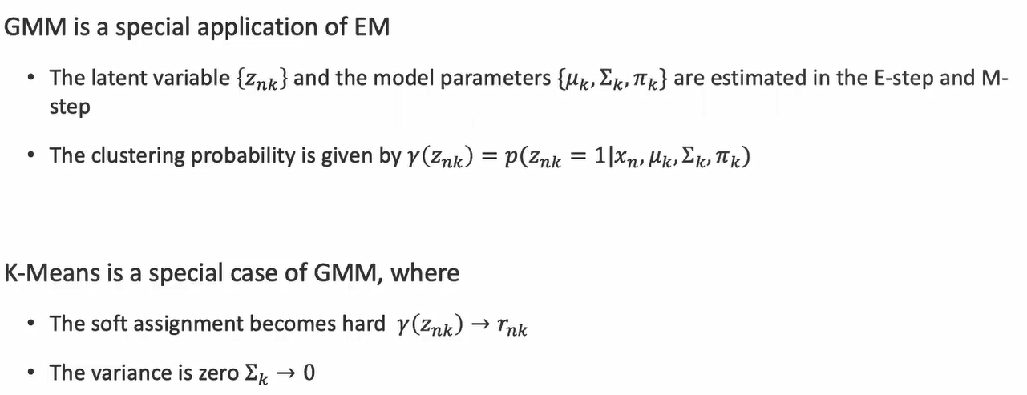

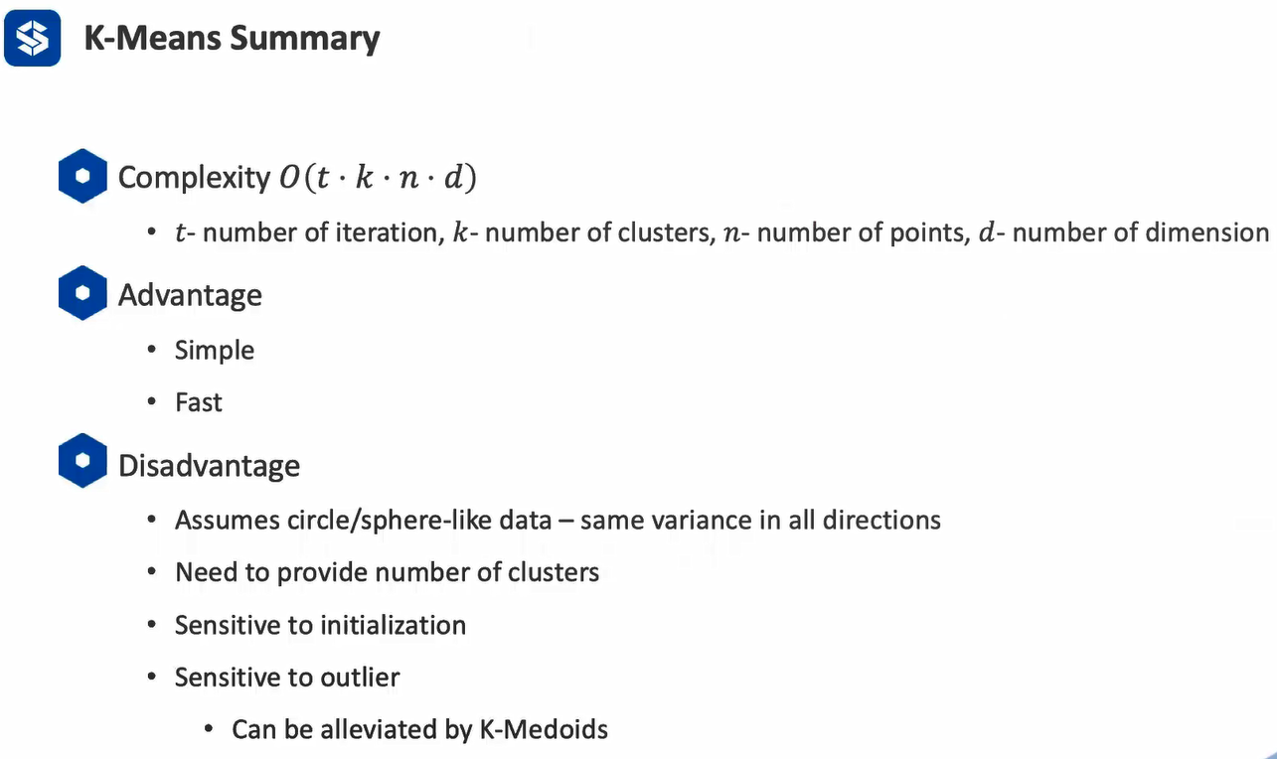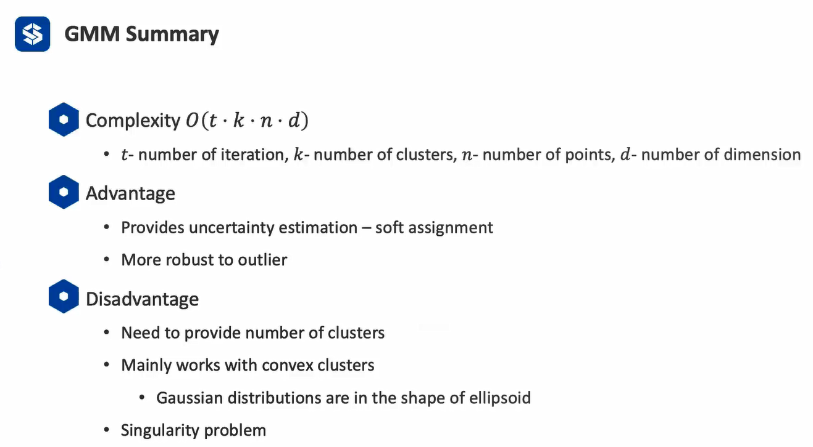

GMM and K-Means are based on Euclidean distance, but they do not perform well for other metrics, i.e., connectivity. Thus, we use spectral clustering to deal with connectivity problems because it focuses on the connectivity between points in a graph (similar to connected block in a graph).

**Spectral Clustering**

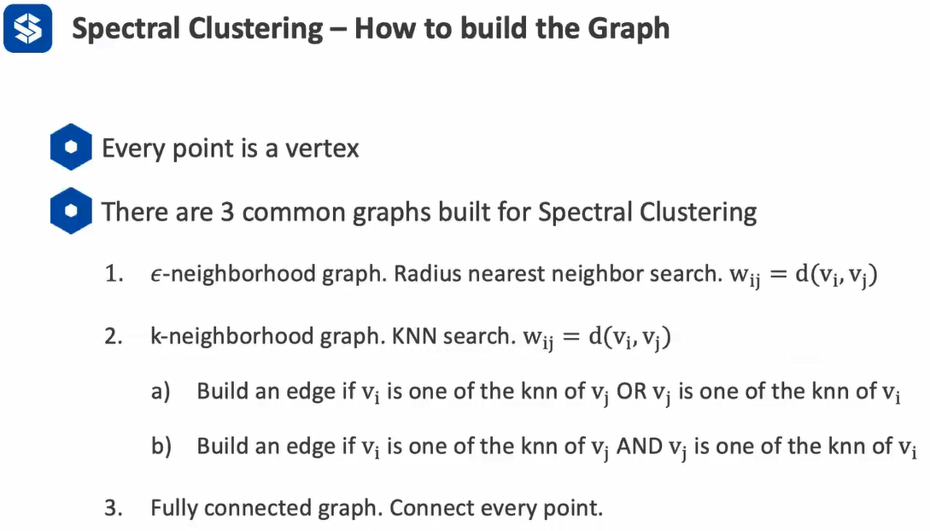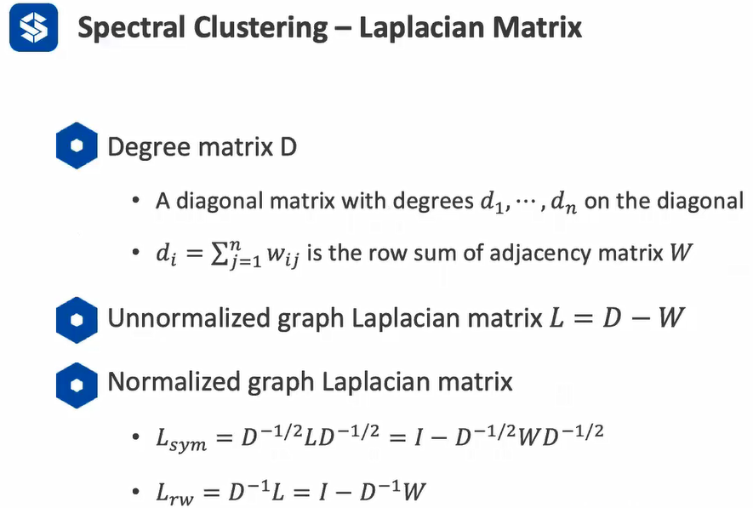

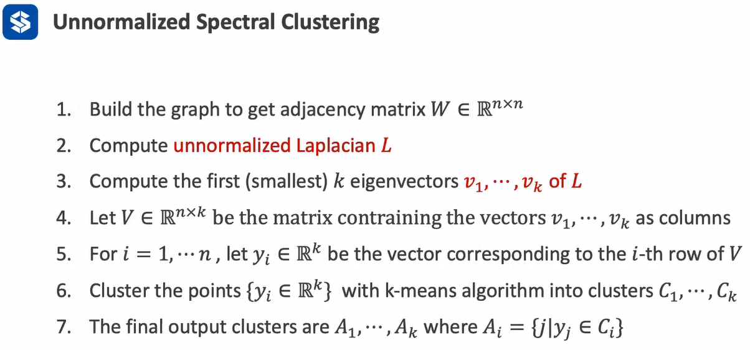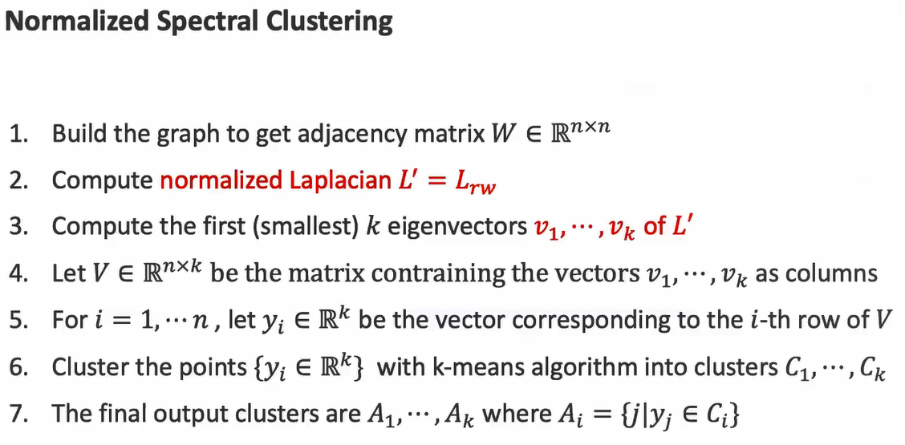

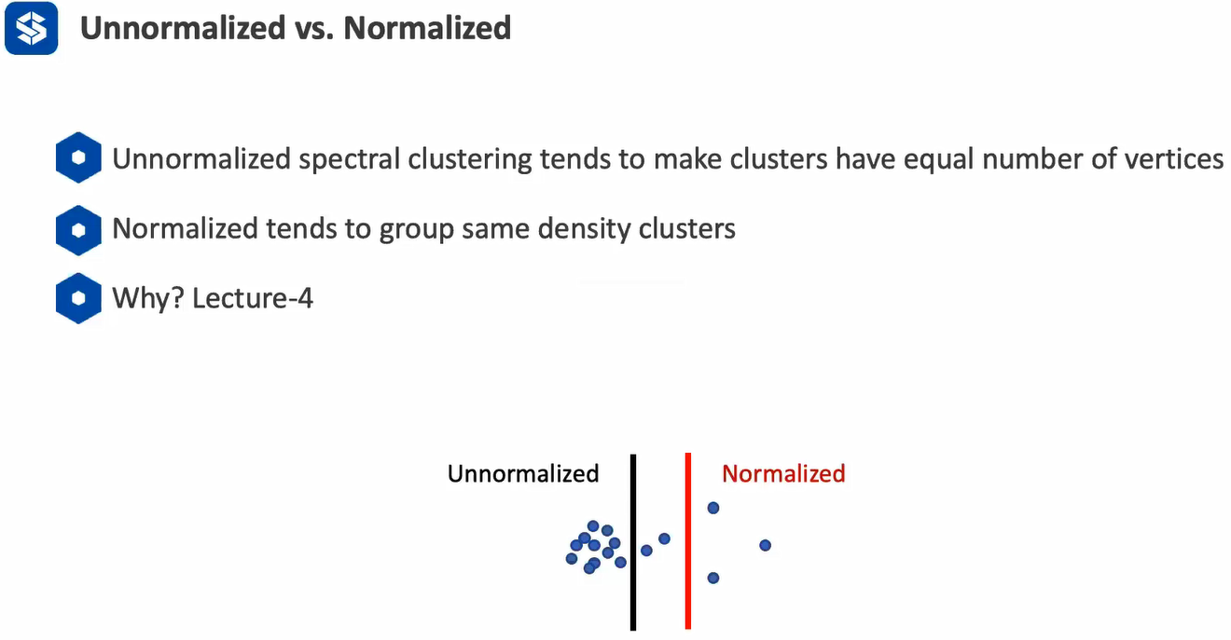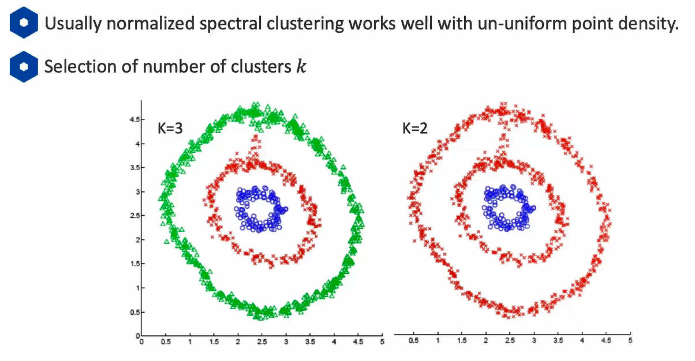

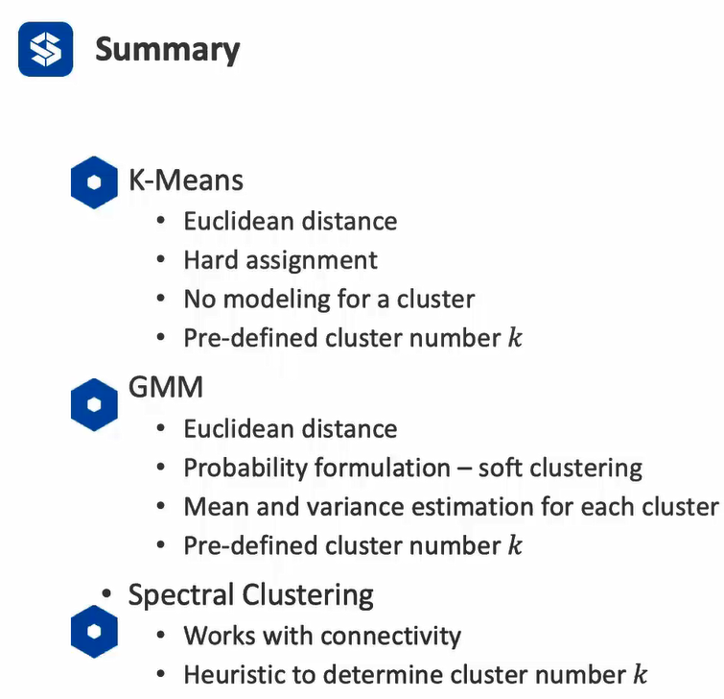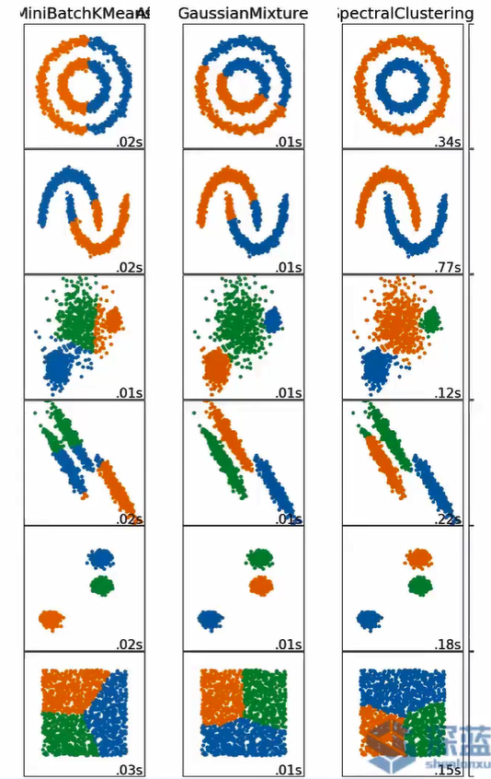

**Lecture 4**

**Spectral Clustering**

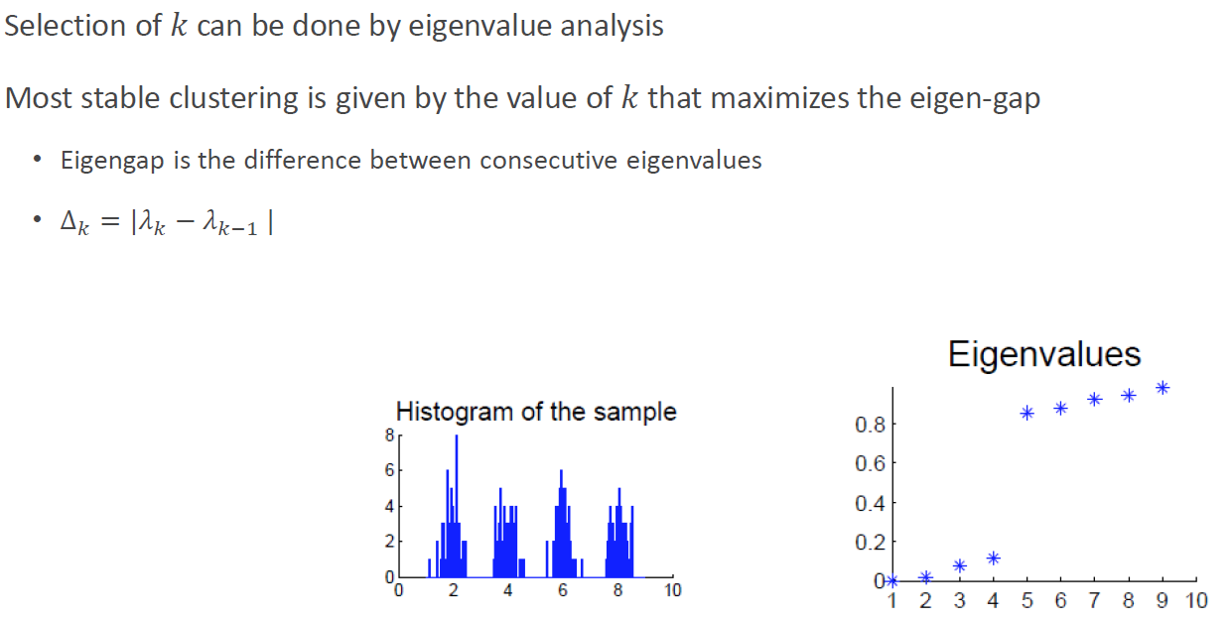

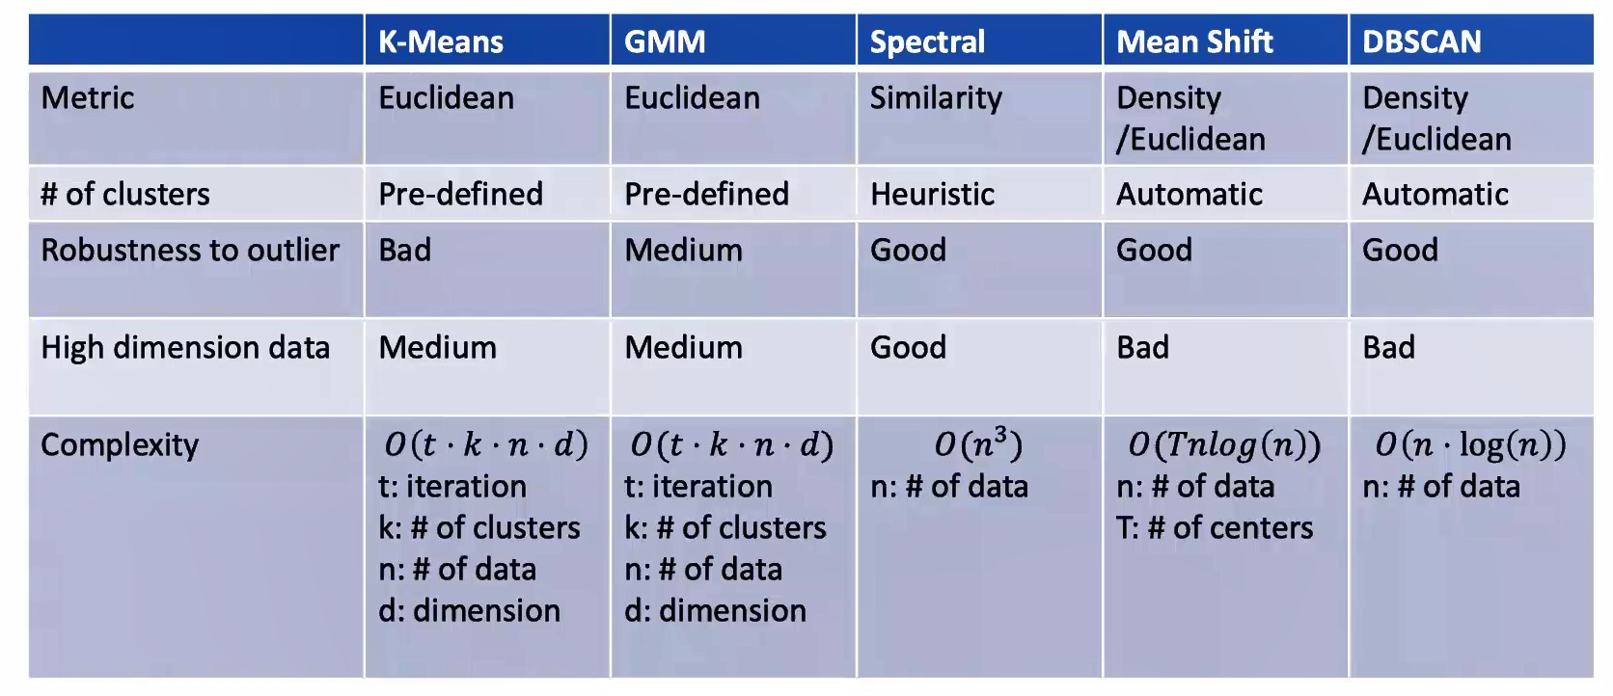

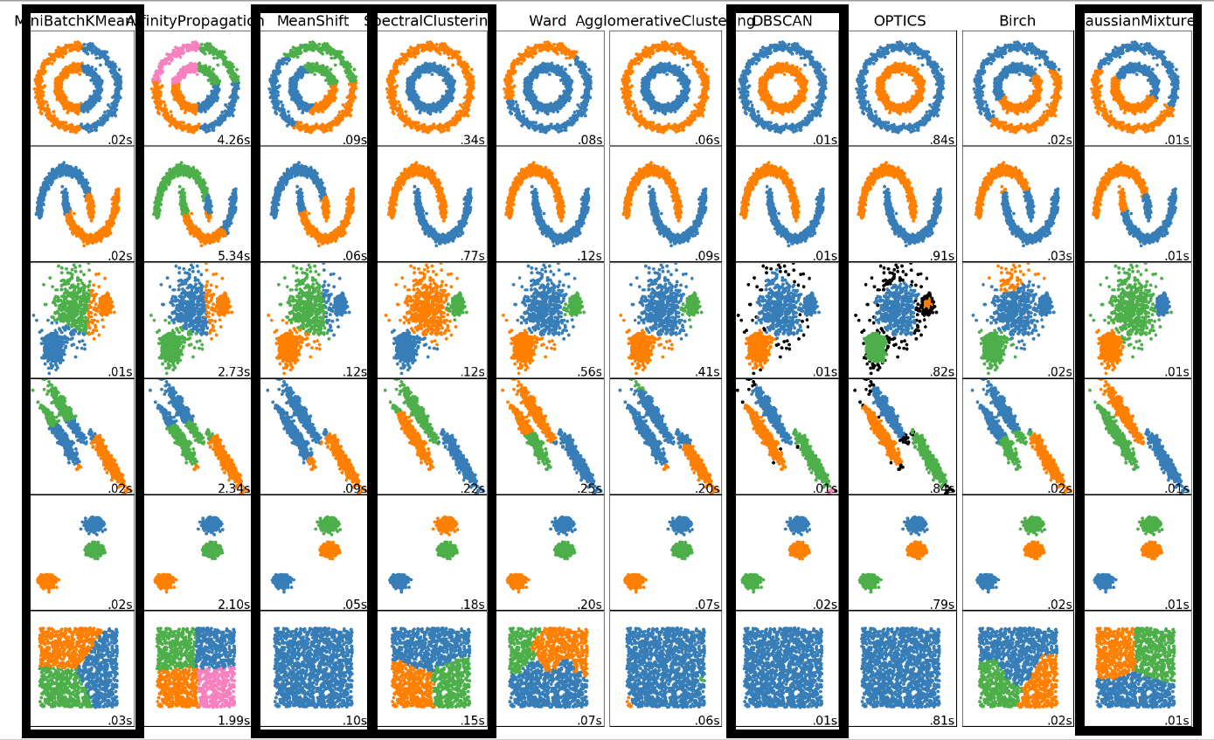

**Summary**

***K-Means***: a special case of GMM (soft assignment 🡪 hard, variance🡪0)

(1) hard assignment, Lack of uncertainty measure of the assignments. (2) pre-defined k (empirical).

(3) sensitive to initialization / outliers. (4) Clustering in Euclidean space (Euclidean distance is not proper for categorical labels).(5) perform poorly in connected space. (6) Use EM steps to cluster the data.

(7) simple, fast.(8) assume circle/sphere-like data, same variance in all directions.

**Gaussian Mixture Model (GMM): a special application of EM**

(1) soft assignment, show the probability of the assignments. (2) pre-defined k (empirical). (3) more robust to outliers. (4) Clustering in Euclidean space (Euclidean distance is not proper for categorical labels).(5) perform poorly in connected space. Perform well with gaussian-like data distribution.(6) Use EM steps to cluster the data. (7) singularity problem when using maximum likelihood

**Spectral Clustering:**

(1) focus more on connectivity. (2) expand a cluster in a graph. (3) no predefined k. (4) works with similarity, including Euclidean and connectivity. (5) works with any dimensional data. (6) able to estimate the number of clusters. (7) computational expensive.

**Mean-shift:**

(1) sliding window hill climbing. (2) randomly select a circle with a radius. Consider all the points in the circle, compute the mean as the next center point. (3) use NMS to remove overlapping circles.

(4) determine the clusters automatically. (5) robust to outliers (6) hill climbing easily falls in local minima

(7) depends on initialization (8) assume clusters are in ellipse shape (9) mainly works in Euclidean space

(10) does not scale with high dimension data

**Density-based Spatial Clustering of Application with Noise (DBSCAN):**

(1) use core points, outlier, bord to expand in the data (2) expand for each core points (3) no predefined k (4) no assumption on cluster shape (5) robust to outliers (6) does not work well with varying density. i.e., two big clusters with a tiny link, then all of them will be considered a cluster. (7) mainly works in Euclidean space (8) does not scale with high dimensional data.

**Model Fitting**

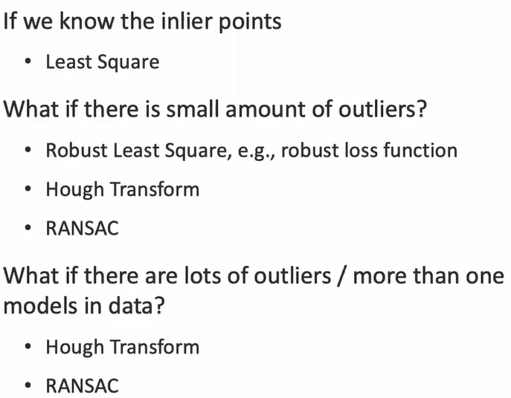

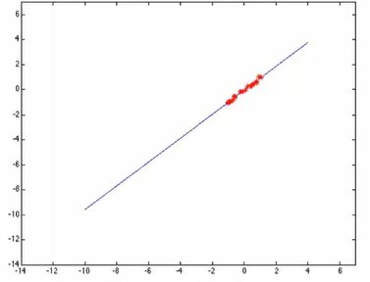 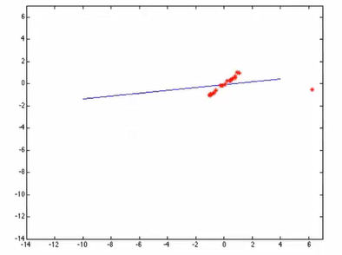 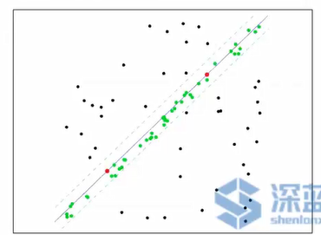

**Hough Transform**

Most widely application of Hough Transform in image is to compute the lines. Points in original space can be transformed to lines in parameter space, vice verse.

